





prepared for

Interaction Studio Pilot for Brazil Mais Abracos Blueprint

Contents

Revision Tracking 3

Contact Information 4

Kimberly-Clark Contact Information 4

Approval Tracking 4

Common Acronyms 5

1. Conceptual Design Section 6

1.1 Project Summary: Solution Overview 7

1.1.1 Data Flow Overview: 7

1.1.2 Interaction Studio Architecture 7

2. Configuration Specification 11

2.1 Foundational Components 12

2.1.1 General setup 12

2.1.2 Identity types 12

2.1.3 User Attributes 13

2.1.4 Catalog and profile objects 13

2.1.5 Manage SFTP Configuration 14

2.1.6 Web Beacon and Sitemap 14

a) Beacon URL and Location 14

b) Sitemap code 15

c) Dataset 17

2.1.7 Integrate Data 18

a) FTP 18

b) Journey Builder 18

2.1.8 Web Template and Campaign Configuration 18

a) Web Template code 20

Handlebar (HTML) 20

CSS 26

Clientside Code 34

Serverside Code 44

b) Campaign Configurations 47

Unknown User 47

Known User 48

Email Response 49

2.1.9 User Segments 50

a) Configuration 50

b) Export a Segment to the Interaction Studio SFTP 52

c) Send a User to Journey Builder Upon Segment Join 52

# Revision Tracking

|  |  |  |  |  |
| --- | --- | --- | --- | --- |
| Date | Version | Description | Author | Audience |
|  |  |  |  |  |
|  |  |  |  |  |

# Contact Information

### Kimberly-Clark Contact Information

|  |  |  |
| --- | --- | --- |
| Name | Title | Email |
|  |  |  |
|  |  |  |

# Approval Tracking

|  |  |  |  |
| --- | --- | --- | --- |
| Document Section | Description | Kimberly-Clark Approver | Approval Date |
| 1.0 | Overall Blueprint | KCC |  |
|  |  |  |  |

# Common Acronyms

Theses Acronyms are commonly used throughout the Blueprint documentation and in communications about the solution implementation.

|  |  |
| --- | --- |
| Acronym | Definition |
| CSV | Comma Separated Values |
| DE | Data Extension |
| Access Control | Is the management of access to interfaces and network resources. |
| Connector | Facilitate integration of your MuleSoft applications with any external resource, |
| API | Application Programming Interface |
| Batch Processing | The execution of a series of programs without manual intervention |
| Cloud Integration | Allows for applications to connect with and share data with one another in the cloud |
| Data Encryption | The process of using algorithms or ciphers to protect electronic communication |
| VPN | Virtual Private Network |
|  |  |
|  |  |
|  |  |
|  |  |

# Conceptual Design Section

The purpose of this section is to outline the overall solution, beginning with a high-level overview and followed by comprehensive visuals and descriptions of each of the respective components.

The intended audience of this section is any of the key stakeholders, or those who will be responsible for the administration of any of these components.

## Project Summary: Solution Overview

**Goal(s):**

K-C has identified a data capture moment for new and existing consumers coming to Mais Abracos as an opportunity to create a proof-of-concept (POC) for the use of Salesforce Interaction Studio (SFIS) real-time personalization. The POC is focused on proving the hypothesis that increasing the first-party data capture rate would deliver more relevant experiences, increase content engagement, and ultimately result in business growth.

**Approach:**

Accenture Interactive, working in collaboration with Salesforce and K-C, to support the strategy, design of the creative assets, integration of the Salesforce Interaction Studio, dashboard setup, and analyses of the results.

### Data Flow Overview:

### Interaction Studio Architecture

Interaction Studio Web SDK

The Interaction Studio Web SDK provides functions, properties, and methods to track user behavior on your website and send that behavioral information to Interaction Studio, enabling you to build website user or visitor behavior profiles. The JavaScript beacon included with the Web SDK handles event responses containing personalization web [Campaigns](https://developer.evergage.com/campaign-development). Business users develop these Campaigns through the Interaction Studio UI for display on the website to qualified visitors and leverage [Campaign Templates](https://developer.evergage.com/campaign-development/web-templates) to load data, run machine learning, perform A/B testing, and run client-side display logic.

A/B testing

A form of statistical hypothesis testing with two variants: test and control. Within Interaction Studio, the term A/B testing is used to more broadly define any campaign that uses a randomized split in visitor traffic to test a hypothesis. With A/B Testing you can split traffic randomly into different groups and show each group different variations of a message. This is done by creating multiple experiences, then assigning each a set percentage of visitor traffic.

Beacon

The Interaction Studio JavaScript beacon places a first party cookie on the visitor's browser which sends data for that visitor back to Interaction Studio. This includes pages visited, links clicked, time on site, number of visits, geolocation, and referral source, as well as other custom data you want collected. There are two ways you can integrate the Interaction Studio JavaScript Beacon:

**Synchronous** – this integration loads the beacon before the page loads so Interaction Studio can prevent page flicker, a momentary flash of the original page content

Content zone

This is an area on your site that a developer has configured in the sitemap to make it eligible for personalization - for example, a homepage hero (personalized offers or recommendation) or PDP product recommendations row (similar items on PDP)

Dataset

Datasets in Interaction Studio are collections of events, catalog configurations, and user profiles, which keep Interaction Studio data separate and organized. Within your account, you may set up multiple datasets. Data sent to one dataset is separate from data in other datasets, so you can understand customer engagement differently.

ETL

This acronym stands for extract, transform, load and is the process used to pull data out of other systems and into Interaction Studio and push data out of Interaction Studio and into other systems. This type of data processing is often used to build a data warehouse.

Event

Includes any interaction a visitor has with your site. An event is everything that a visitor does - a click, a page load, and a message view which is also called an “impression.”

Evergage Launcher

The Evergage Launcher is a Google Chrome browser extension you'll use to add personalization features to your website. Using developer created templates, you can create personalization campaigns targeted to specific groups, individual users, or events.

Experience

You can create different personalization results within the same campaign using Experiences. For example, suppose you would like to create a campaign for first time visitors to your site, but you want to show different message to visitors from Boston and San Francisco because you have events coming up in those two cities. You would create 3 experiences in the same campaign: one for Boston visitors, one for visitors from San Francisco, and one for visitors from everywhere else. Then, you’d use rules to control the visibility of these experiences.

JavaScript Beacon

A snippet of code provided to you by Interaction Studio that you add to your site. The beacon places a first party cookie on each visitor’s browser and sends data for that visitor back to Interaction Studio. The data sent back includes pages visited, links clicked, time on the site, number of visits, geolocation, referral source, as well as other custom data you want collected.

Impressions

How many times the campaign was seen. This may be greater than the number of unique visitors since they may see a campaign more than once.

Segments

Real-time grouping of accounts or individuals based on a set of criteria you define. You can use segments for many things including analytics, campaign goals, and even to set parameters for rule-based campaigns. Segment updates happen in real-time, so any membership changes occur immediately, even during the same visit. Segments can be user or account based.

**User segments** - Segments of individuals who visit your site or log into your application

You can use segments declared as filters can be utilized to filter important reports. Segments declared as goals can be applied to campaigns for measuring lift. For the sake of reporting, goal segments will also be considered filter segments.

Sitemap

The Interaction Studio [Sitemap](https://developer.evergage.com/web-integration/sitemap) system is a configuration driven integration layer that is deployed by and executes within the Interaction Studio beacon. A "sitemap" is developed to integrate with a specific site using the APIs provided, which map key business objects into Interaction Studio through event capture. This can include page type information and catalog items, supporting the ability to understand user interests against the catalog. It includes items such as products, article content, and categories, and can also include custom dimensions (categorical information about items with custom attributes). See the Interaction Studio [Data Model](https://developer.evergage.com/data-model) for more details. Situational data includes data such as a visitor's referring site, email or ad campaign source, IP address, geo-location, device type and operating system.

User

A visitor to a Client website.

Visits

Counts all visitors’ sessions on your site, regardless of how many times the same visitor may have been to your site.

Visitors

Represents the individual user or visitor to your site. In reports, the visitors statistic shows you the number of unique daily visitors and the number of visits during the set timeframe. You’ll also see an indicator showing whether traffic is up or down, where visitors are coming from, and whether they are known or anonymous users

Visual Editor

Google Chrome browser extension that overlays campaign creation and editing on your website or application. The Visual Editor makes it easy to “see” your edits since they appear on your site as you create your personalization messages.

Web campaign

During the web campaign development process, a business user can modify configurable inputs in a web template to create and deploy 1:1 personalized interactions. When a business user creates a new campaign and selects a template, s/he then completes the inputs available for that template, adds qualification criteria rules, and then publishes the campaign. The published campaign is visible to visitors that qualify based on the testing and targeting logic you set when you create the campaign. For example, suppose you want to create an infobar promoting free shipping and returns. You would create a campaign, add the infobar template, complete the inputs specific to that template, add any qualification rules, and publish the campaign.

Web campaign experience

An experience is just as it sounds - it is the "experience" a visitor has with a particular web personalization or activation campaign. You can use experiences to create different personalization results within the same campaign. For example, suppose you would like to create a campaign for first time visitors to your site, but you want to show different copy and images to visitors from different geographical regions or different industries. Using one campaign, you could create separate experiences, each targeting a different subset of your website visitors. Then, you’d use rules to control the visibility of each experience.

Web campaign & experience rules

These control the visibility of a campaign to individuals and audiences. There are many combinations of rules, which are documented in [Use Targeting Rules for Web Campaigns](https://doc.evergage.com/display/EKB/Use+Targeting+Rules+for+Web+Campaigns), and they can be used regardless of the testing type you use for your campaign.

Web template

A Web template offers a developer-built, fully QA'ed, repeatable framework that you can use to create web personalization campaigns. Templates define what a campaign can render, such as promotional assets, product recommendations, message copy, and images. It also defines what campaign creators can configure, such as the algorithms powering the recommendations, message copy, and call to action copy, or even the presence of a CTA button.

# Configuration Specification

The purpose of this section is to define the configuration components of the solution as they exist in the Interaction Studio.

The intended audience of this section is those who will be responsible for the administration of any of these components. Those individuals with a technical role in the administration will gain the most from this section of the document.

## Foundational Components

### General setup

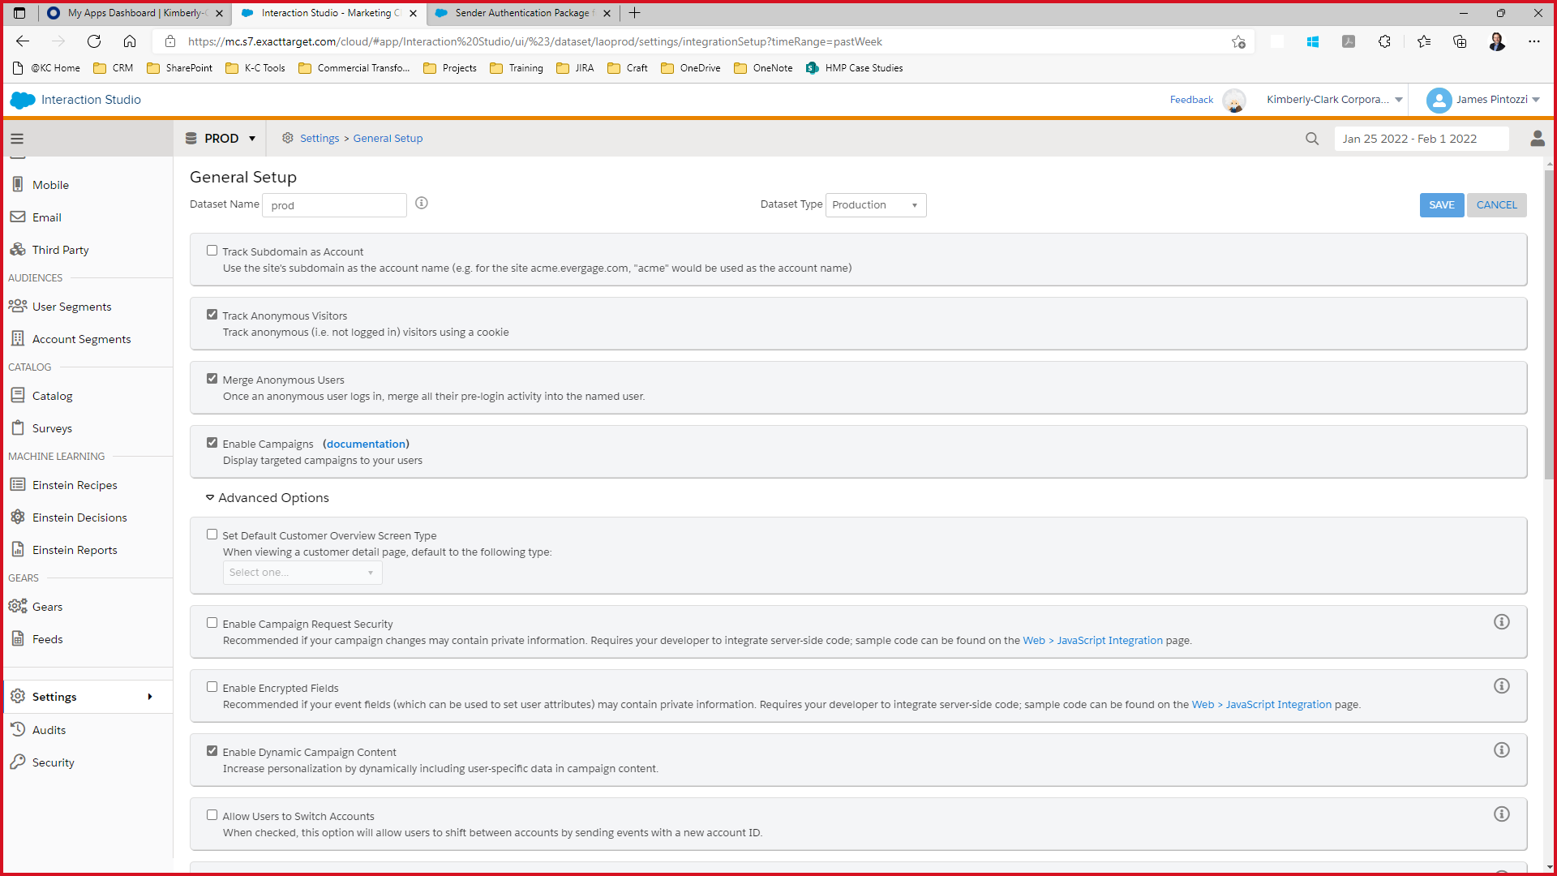

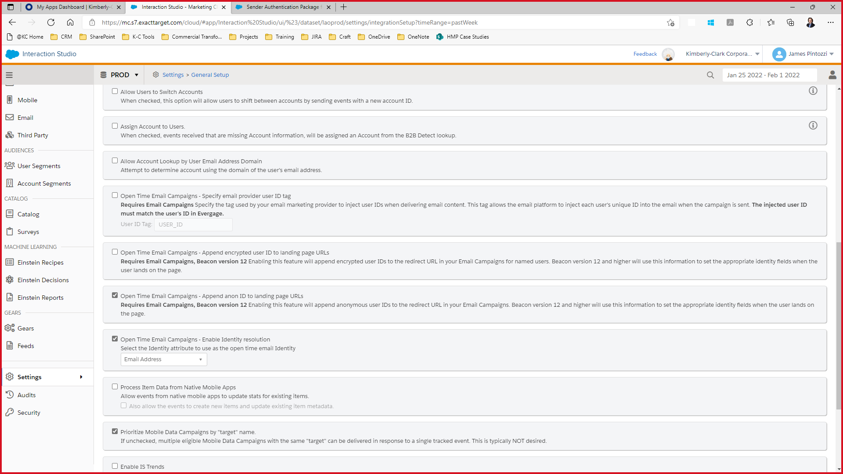

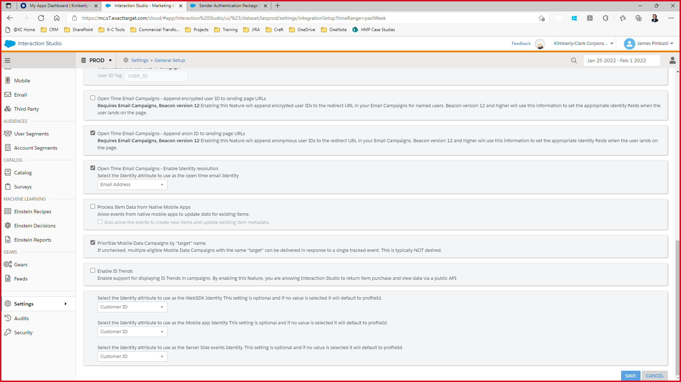

### Identity types

Using the Interaction Studio [Identity System](https://doc.evergage.com/display/EKB/Configure+Identity+Types+and+Attributes), you can configure the identifiers that determine a unique known individual within Interaction Studio. You can configure Interaction Studio to support multiple identifiers for lookup and user merge. The provided identifiers determine how events are applied to visitor profiles whether originating from a web event, a feed import, or another channel.

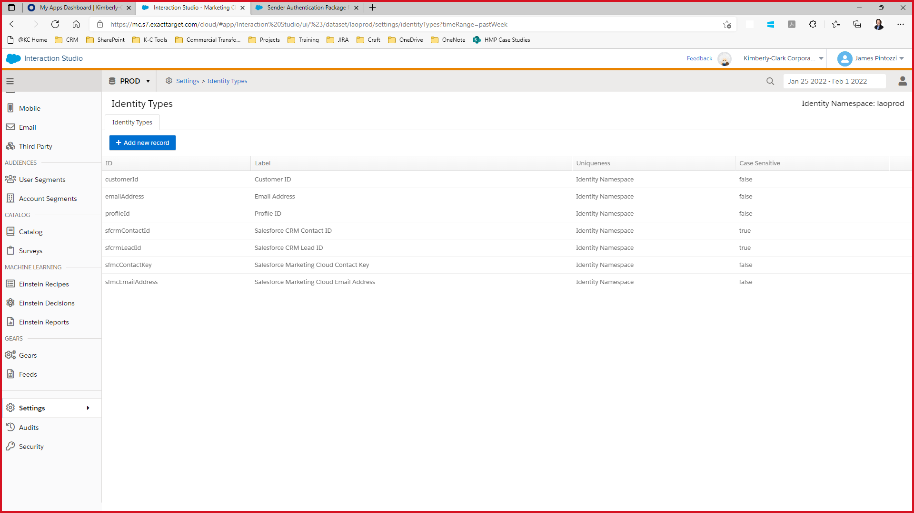

### User Attributes

Interaction Studio user attributes can be used collect data for use in segmentation, reporting, or in integrated third party systems. For example, if you created a form in Interaction Studio, you can assign each field to an already created attribute. Depending on the configuration of your dataset, this attribute will either collect the data for availability in reporting, or can write it back to the third-party integrated system.

More information [here](https://doc.evergage.com/display/EKB/Modify+Attributes+at+the+User+or+Account+Level)

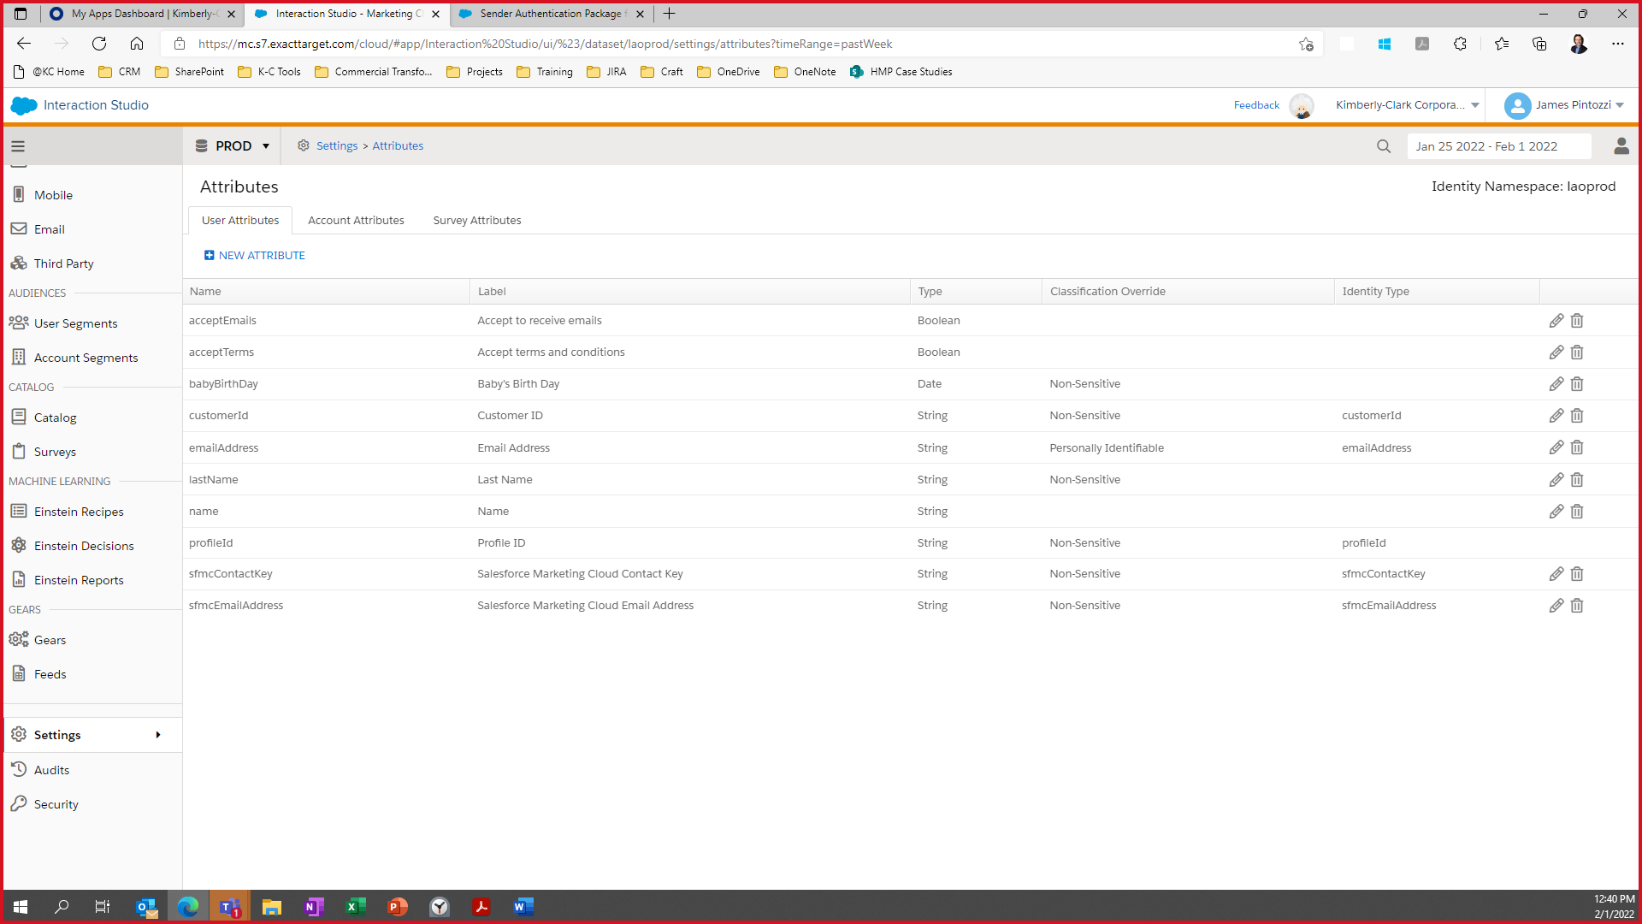

### Catalog and profile objects

The Interaction Studio Catalog is accessible by navigating to **Settings > Catalog and Profile Objects** in the left-hand navigation. On this screen, a customer will be able to configure baseline catalog settings, create/configure catalog object types, and create/configure profile object types. This [article](https://doc.evergage.com/display/EKB/Catalog+Object+Setup) will cover catalog object configuration and a separate article will cover profile objects.

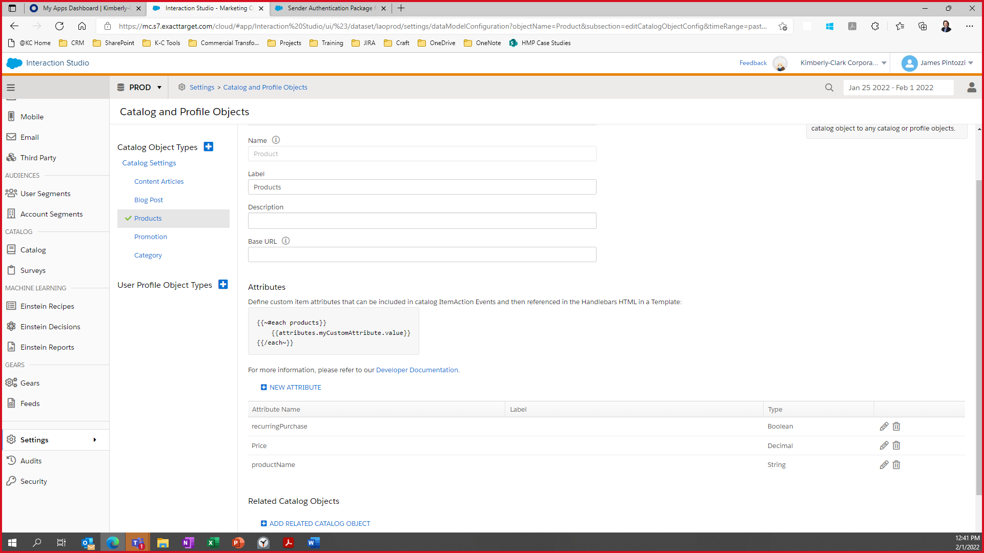

### Manage SFTP Configuration

Send and receive data from an automated platform, safely and securely. Create new SFTP user accounts as needed with just a few clicks, then add credentials to your FTP client to begin transferring files through the [Interaction Studio ETL system](https://doc.evergage.com/display/EKB/Manage+SFTP+Users).

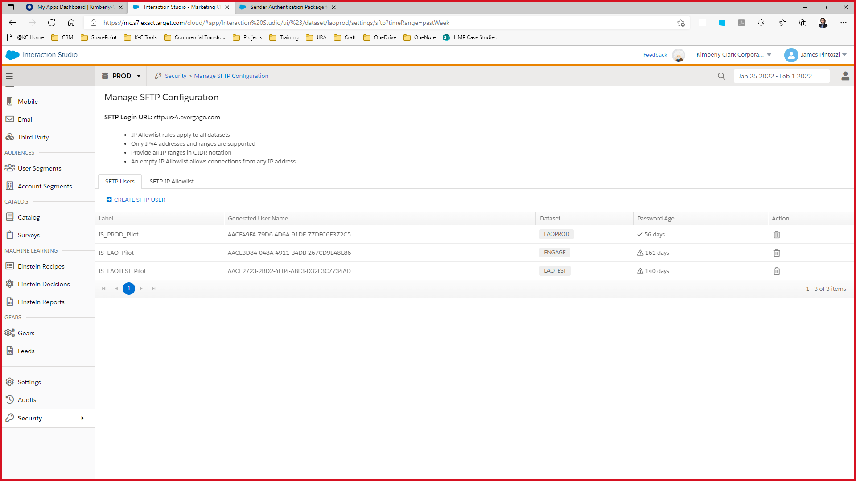

### Web Beacon and Sitemap

The Interaction Studio JavaScript beacon places a first party cookie on the visitor's browser which sends data for that visitor back to Interaction Studio. This includes pages visited, links clicked, time on site, number of visits, geolocation, and referral source, as well as other custom data you want collected.

#### Beacon URL and Location

* Log into Interaction Studio as an *administrator*
* Select **Web**>**JavaScript Integration**
* If you have more than one dataset, select the one you want from the dropdown at the top left of the Interaction Studio window
* Select the tab for the beacon type: **Synchronous**
* Copy the code as directed on the screen and place it into the HTML head element of your site to ensure that the beacon is loaded on every page of the site

<script type="text/javascript" src="//cdn.evgnet.com/beacon/kimberlyclark/laoprod/scripts/evergage.min.js"></script>

More information [here](https://doc.evergage.com/display/EKB/Install+the+JavaScript+Beacon)

#### Sitemap code

An Interaction Studio Sitemap is a configuration-driven system deployed by and executed within the Interaction Studio JavaScript Web SDK. The Sitemap configuration data enables other parts of the Interaction Studio platform to register and receive events from the client context. This article provides guidance for configuring the JavaScript components of a Sitemap required to implement the Interaction Studio web channel solution architecture. For a more comprehensive introduction to the Sitemap, see [Sitemap Overview](https://developer.evergage.com/web-integration/sitemap).

*Evergage.init({ // Initializes the Interaction Studio Web SDK*

*}).then(() => {*

*const sitemapConfig = { // Sitemap configuration object*

*global: {*

*contentZones: [*

*{ name: "global_popup" }*

*],*

*}, // Object used to contain Global site object config*

*pageTypeDefault: {*

*name: "default"*

*},*

*pageTypes: [*

*{*

*name: "home",*

*action: "Homepage",*

*isMatch: () => /\/homepage/.test(window.location.href),*

*},*

*{*

*name: "babyshower",*

*action: "Baby Shower",*

*isMatch: () => /\/baby-shower-mais-abracos-br/.test(window.location.href),*

*},*

*{*

*name: "mypregnancy",*

*action: "My Pregnancy",*

*isMatch: () => /\/minha-gravidez/.test(window.location.href),*

*},*

*{*

*name: "mybaby",*

*action: "My Baby",*

*isMatch: () => /\/meu-bebe/.test(window.location.href),*

*},*

*{*

*name: "products",*

*action: "Products",*

*isMatch: () => /\/produtos/.test(window.location.href),*

*},*

*{*

*name: "signin",*

*action: "Sign In",*

*isMatch: () => /\/iniciarsessao/.test(window.location.href),*

*listeners: [*

*Evergage.listener("click", "form[name='login-form'] button", () => {*

*const email = Evergage.cashDom("#login-form-email").val();*

*if (email) {*

*const datP = new Date();*

*datP.setTime(datP.getTime() + (730*24*60*60*1000));*

*let expires = "expires="+ datP.toUTCString();*

*document.cookie = "_evga_email" + "=" + email + ";path=/;" + expires;*

*Evergage.sendEvent(*

*{*

*action: "Logged In - IS",*

*user: {*

*attributes: {*

*id: email,*

*emailAddress: email,*

*customerId: email*

*}*

*}*

*}*

*);*

*}*

*}),*

*Evergage.listener("click", "form[name='dwfrm_profile'] button", () => {*

*const name = Evergage.cashDom("#registration-form-fname").val();*

*const lastName = Evergage.cashDom("#registration-form-lname").val();*

*const email = Evergage.cashDom("#registration-form-email").val();*

*let accept_terms = document.getElementById("accept-terms").checked;*

*let add_to_email_list = document.getElementById("add-to-email-list").checked;*

*let str = document.querySelector('input[name="dwfrm_profile_customer_additionalFields_childDOB"]').value;*

*//let str = Evergage.cashDom("#dwfrm_profile_customer_additionalFields_childDOB").val();*

*if (name && lastName && email && str) {*

*let d = str.substring(0, 2);*

*let m = str.substring(3, 5);*

*let y = str.substring(6, 10);*

*let s = '-';*

*let f = 'T00:00:00';*

*const dob = y.concat(s, m, s, d, f);*

*const datP = new Date();*

*datP.setTime(datP.getTime() + (730*24*60*60*1000));*

*let expires = "expires="+ datP.toUTCString();*

*document.cookie = "_evga_email" + "=" + email + ";path=/;" + expires;*

*document.cookie = "_evga_Bdob" + "=" + str + ";path=/;" + expires;*

*document.cookie = "_evga_name" + "=" + name + ";path=/;" + expires;*

*Evergage.sendEvent(*

*{*

*action: "Create New Account - IS",*

*user: {*

*attributes: {*

*id: email,*

*emailAddress: email,*

*customerId: email,*

*name: name,*

*lastName: lastName,*

*babyBirthDay: dob,*

*acceptTerms : accept_terms,*

*acceptEmails : add_to_email_list*

*}*

*}*

*}*

*);*

*}*

*})*

*]*

*},*

*] // Array used to contain the page type object configs*

*}*

*Evergage.initSitemap(sitemapConfig); // Initializes the Sitemap*

*});*

#### Dataset

Datasets in Interaction Studio are collections of events, catalog configurations, and user profiles, which keep Interaction Studio data separate and organized. Within your account, you may set up multiple datasets. Data sent to one dataset is separate from data in other datasets, so you can understand customer engagement differently.

* Log into Interaction Studio as an administrator or with "Configure Dataset" permissions.
* Click the avatar icon in the top right corner of the window, or click on the dataset indicated at the top of the screen (for example, "Engage").
* Select Manage Datasets.

In our case, we use 2 datasets:

Dev and Staging: laotest

Production: prod

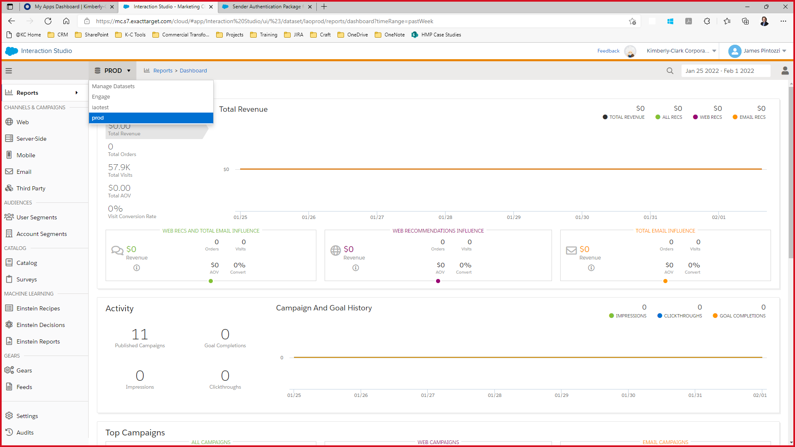

More information [here](https://doc.evergage.com/display/EKB/Set+up+and+Manage+Datasets)

### Integrate Data

#### FTP

Records the information of all clients.

More information in section Export a Segment to the Interaction Studio SFTP

#### Journey Builder

For sending coupon emails, or email popup response.

More information in section Send a User to Journey Builder Upon Segment Join

### Web Template and Campaign Configuration

* **Web template**—a template offers a developer-built, fully QA'ed, repeatable framework that you can use to create personalization campaigns. Templates define what a campaign can render, such as promotional assets, product recommendations, copy, and images along with what business users can edit such as the algorithms powering the recommendations, message copy, and CTA copy. For example, a developer could create a template for a PDP Recommendations bar so the business user could define the title of the bar and the algorithm driving the recommendations. Or, a developer could create an email capture template so the business user could enter the header and sub-header text, along with various CTA options, then create an A/B test to determine which CTA gets the best result.
* **Content zone**—this is an area on your site that a developer has configured in the site map to make it eligible for personalization - for example, a homepage hero (personalized offers or recommendation) or PDP product recommendations row (similar items on PDP)
* **Web campaign**—during the web campaign development process, a business user can modify configurable inputs in a web template to create and deploy 1:1 personalized interactions. When a business user creates a new campaign and selects a template, s/he then completes the inputs available for that template, adds qualification criteria rules, and then publishes the campaign. The published campaign is visible to visitors that qualify based on the testing and targeting logic you set when you create the campaign. For example, suppose you want to create an infobar promoting free shipping and returns. You would create a campaign, add the infobar template, complete the inputs specific to that template, add any qualification rules, and publish the campaign.
* **Web campaign experience**—an experience is just as it sounds - it is the "experience" a visitor has with a particular web personalization or activation campaign. You can use experiences to create different personalization results within the same campaign. For example, suppose you would like to create a campaign for first time visitors to your site, but you want to show different copy and images to visitors from different geographical regions or different industries. Using one campaign, you could create separate experiences, each targeting a different subset of your website visitors. Then, you’d use rules to control the visibility of each experience.

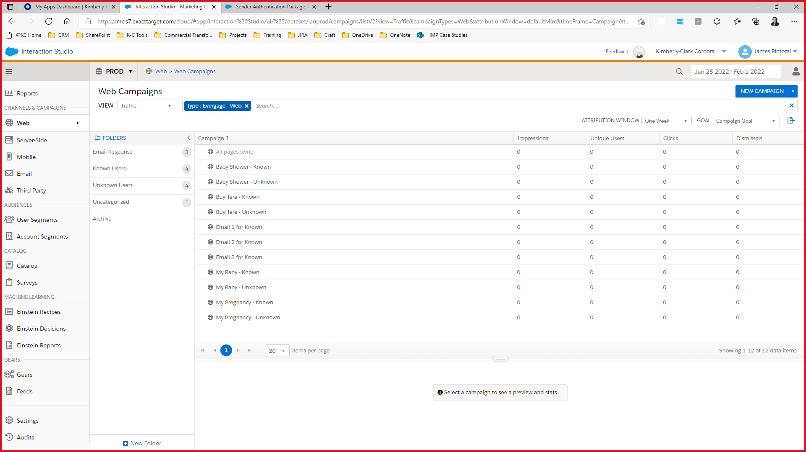

* **Web campaign & experience rules**—these control the visibility of a campaign to individuals and audiences. There are many combinations of rules, which are documented in [*Use Targeting Rules for Web Campaigns*](https://doc.evergage.com/display/EKB/Use+Targeting+Rules+for+Web+Campaigns), and they can be used regardless of the testing type you use for your campaign

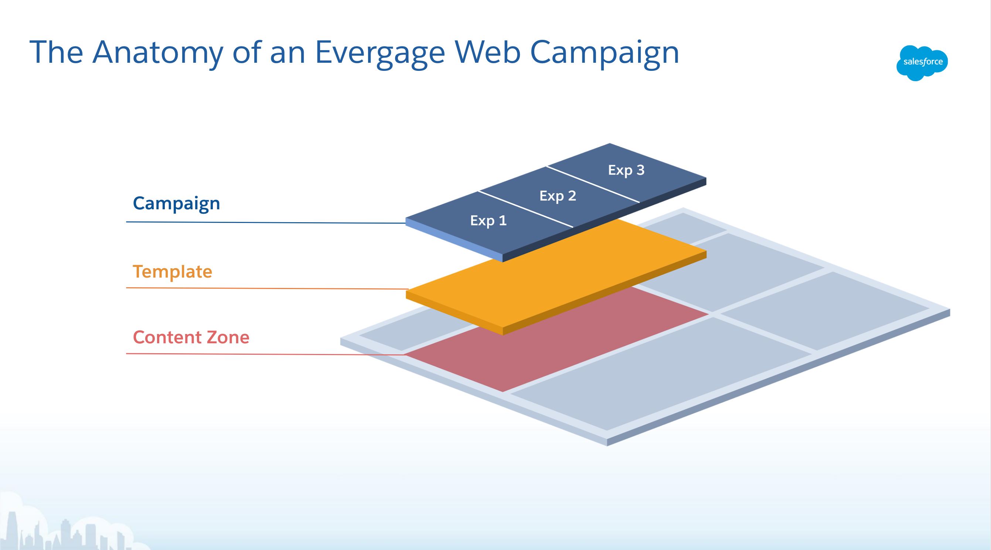

#### Web Template code

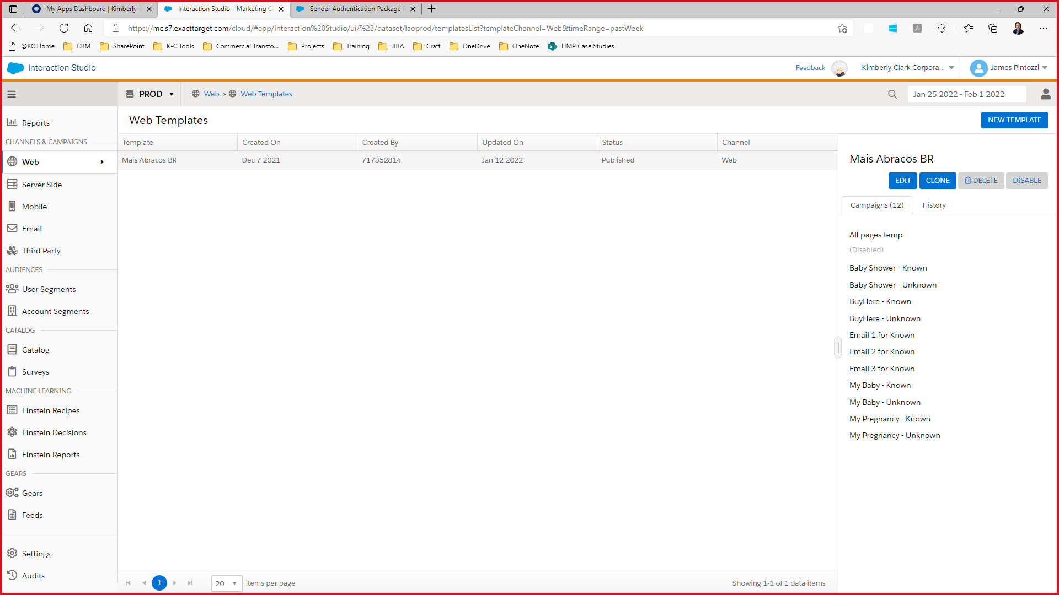

##### Handlebar (HTML)

*{{!--*

*Global Template: Exit Intent Pop-Up with Email Capture*

*This global template displays a popup with an email capture when a user intends to exit the page.*

*There are two default Styles: Dark text for lighter backgrounds or light text on darker backgrounds.*

*Requirements:*

*1) Set the content zone(s) to that defined in your Sitemap.*

*2) Create a user attribute `emailAddress` to save the user's email to.*

*Customizations:*

*1) As a best practice, set the content zone to "global_popup".*

*See https://developer.evergage.com/web-integration/sitemap/contentzones for recommended names for content zones*

*mapped via the Sitemap.*

*2) Style options can be changed in Serverside Code.*

*3) Styling of the Style options, including fallback background color, can be changed in CSS.*

*4) Remove or change the default values for the configuration properties in Serverside Code.*

*5) Once validated, the user's email address will be sent to Interaction Studio and set to the user's*

*emailAddress attribute.*

*6) Media query breakpoints can be changed in CSS.*

*7) To support rich text, add the @richtext(true) decorator to configuration properties in Serverside Code.*

*Handlebars expressions for these properties must be wrapped in three sets of curly braces (e.g. {{{expression}}} ).*

*8) Change the value of the aria-label attributes as necessary.*

*9) Change the error message in the .evg-error-msg. Styling can be changed in CSS.*

*--}}*

*<link rel="stylesheet" href="https://staging-na01-kimberlyclark.demandware.net/on/demandware.static/Sites-MaisAbracos_BR-Site/-/pt_BR/v1629492053450/css/global.css" data-cssvars />*

*<link rel="stylesheet" href="https://staging-na01-kimberlyclark.demandware.net/on/demandware.static/Sites-MaisAbracos_BR-Site/-/pt_BR/v1629492053450/css/login.css" data-cssvars />*

*<div id="evg-exit-intent-popup-email-capture" data-evg-campaign-id="{{campaign}}"*

*data-evg-experience-id="{{experience}}" data-evg-user-group="{{userGroup}}"*

*aria-label="Popup{{#if header}} - {{header}}{{/if}}" role="dialog" aria-modal="true" aria-hidden="false">*

*<div class="evg-overlay" data-evg-dismissal></div>*

*<button class="evg-btn-dismissal showOnMobile" style="display:none;" data-evg-dismissal aria-label="Close Popup" tabindex="7">X</button> <!-- id="mobileClose" -->*

*<form id="maisabracos-form" name="maisabracos-form" class="" autocomplete=off >*

*<div class="evg-popup">*

*<input id="trackName" class="evg-hide" value="{{~trackName~}}" disabled>*

*<input id="trackID" class="evg-hide" value="{{experience}}" disabled>*

*<input id="have_Form" class="evg-hide" value="{{~have_Form~}}" disabled>*

*<input id="its_for_Known_User" class="evg-hide" value="{{~its_for_Known_User~}}" disabled>*

*<input id="have_Thank_You_page" class="evg-hide" value="{{~have_Thank_You_page~}}" disabled>*

*<input id="ctaExitUrl" class="evg-hide" value="{{~ctaExitUrl~}}" disabled>*

*<input id="ctaText" class="evg-hide" value="{{~ctaText~}}" disabled>*

*<input id="ctaExitText" class="evg-hide" value="{{~ctaExitText~}}" disabled>*

*<input id="confirmationCTAText" class="evg-hide" value="{{~confirmationCTAText~}}" disabled>*

*<div class="evg-main-panel">*

*<table style="height: 100%; width: 100%;" cellpadding="0" cellspacing="0">*

*<tr>*

*<td class="evg-main-panel-column noShowOnMobile" style="align=center; valign=top;">*

*<img src="{{imageDesktopUrl}}" style="width: 100%"/>*

*</td>*

*<td class="evg-main-panel-column">*

*<table style="width: 100%; height: 100%;" cellpadding="0" cellspacing="0">*

*<tr>*

*<td class="tablepadding" style="height: 60px; background-color: #da291c;" valign="middle" align="center" >*

*<img src="{{imageMaisAbracosUrl}}" style="height: auto; width: 25%;" />*

*</td>*

*</tr>*

*<tr class="showOnMobile" style="display:none;">*

*<td style="display: block;">*

*<img src="{{imageMobileUrl}}" style="width: 100%; object-fit: cover;"/>*

*</td>*

*</tr>*

*<tr style="vertical-align: bottom;">*

*<td class="tablepadding" style="padding-top: 10px;">*

*{{#if its_for_Known_User}}*

*<div id="section_name">*

*<h1 class="evg-header evg-h1 evg-display-4 evg-style-text" >*

*{{~startUsername~}}<p id="customerName" style="display: inline;"></p>{{~endUsername~}}*

*</h1>*

*</div>*

*{{/if}}*

*<h1 class="evg-header evg-h1 evg-display-4 evg-style-text" >*

*{{~header~}}*

*</h1>*

*</td>*

*</tr>*

*{{#if subheader}}*

*<tr style="vertical-align: top;">*

*<td class="tablepadding">*

*<h2 class="evg-subheader evg-h2 evg-style-text">*

*{{~subheader~}}*

*</h2>*

*</td>*

*</tr>*

*{{/if}}*

*{{#if have_Form}}*

*<tr style="vertical-align: top;" class="tabform">*

*<td class="tablepadding">*

*<div class="form-group required" style="padding-top: 20px;">*

*<h2 class="evg-subheader evg-h2 evg-style-text">*

*{{~formHeader~}}*

*</h2>*

*</div>*

*<div id="section_email" class="form-group required">*

*<input type="email" id="dwfrm_profile_customer_email" name="dwfrm_profile_customer_email" class="form-control email-field fs-mask required evg-input"*

*aria-label="{{~labelEmail~}}" required="" aria-required="true" maxlength="50" tabindex="1" autocomplete="off"*

*data-missing-error="{{~fieldRequiredMessage~}}" data-pattern-mismatch="{{~validationEmailMessage~}}"*

*data-range-error="O m?ximo ? de 50 caracteres" pattern="^[\w.%+-]+@[\w.-]+\.[\w]{2,}$" onchange="changeValue(this);">*

*<label class="form-control-label" for="dwfrm_profile_customer_email">{{~labelEmail~}}</label>*

*<div class="invalid-feedback" id="form-email-error">{{~validationEmailMessage~}}</div>*

*</div>*

*<div class="form-group calendar-simplified required">*

*<input type="text" id="dwfrm_profile_customer_additionalFields_childDOB" name="dwfrm_profile_customer_additionalFields_childDOB" class="form-control js-dob-input js-input-readonly fs-mask required evg-input"*

*data-missing-error="{{~fieldRequiredMessage~}}"*

*data-custom-language="{{lang.value}}" required aria-required="true" value maxLength="2147483647"/>*

*<label class="form-control-label" for="dwfrm_profile_customer_additionalFields_childDOB">{{~labelCalendar~}}</label>*

*<div class="invalid-feedback"></div>*

*<div class="datepicker-calendar">*

*<i class="acf-icon-calendar"></i>*

*</div>*

*</div>*

*<div class="form-group custom-control custom-checkbox kc-custom-control kc-custom-checkbox">*

*<input type="checkbox" id="accept-terms" name="dwfrm_profile_customer_acceptTerms" class="custom-control-input kc-custom-control-input"*

*required aria-required="true" value="true" onchange="changeValue(this);" />*

*<label class="custom-control-label kc-custom-control-label form-control-label" for="accept-terms">*

*<p style="margin-bottom: 0px;">{{~checkText1Start~}}*

*<a class="links" href="{{~termsLink~}}" target="_blank">{{~termsText~}}</a> da*

*<a class="links" href="{{~privacyLink~}}" target="_blank">{{~privacyText~}}</a>*

*{{~checkText1End~}}*

*</p>*

*</label>*

*<div class="invalid-feedback"></div>*

*</div>*

*<div id="check2" class="form-group custom-control custom-checkbox kc-custom-control kc-custom-checkbox">*

*<input type="checkbox" id="add-to-email-list" name="dwfrm_profile_customer_addtoemaillist" class="custom-control-input kc-custom-control-input" value="true" onchange="changeValue(this);" />*

*<label class="custom-control-label kc-custom-control-label form-control-label" for="add-to-email-list">{{~checkText2~}}</label>*

*</div>*

*</td>*

*</tr>*

*<tr style="vertical-align: middle;">*

*<td>*

*<div class="noShowOnMobile">*

*<div class="evg-style-text login" style="margin-top: 2vh;">*

*{{~loginTextStart~}} <a class="links" href="{{~loginUrl~}}" >{{~loginText~}}</a>*

*</div>*

*<div class="form-group ">*

*{{#if have_Thank_You_page}}*

*<button type="button" class="evg-cta" data-evg-clickthrough onsubmit="return false;" aria-label="Submit" disabled>?&nbsp;{{~ctaText~}}</button>*

*{{else}}*

*<button type="button" class="evg-confirm-cta" data-evg-clickthrough onsubmit="return false;" disabled>?&nbsp;{{~ctaExitText~}}</button>*

*{{/if}}*

*</div>*

*</div>*

*</td>*

*</tr>*

*{{else}}*

*<tr style="height: 100px; vertical-align: top;">*

*<td>*

*<div class="noShowOnMobile">*

*<div class="evg-style-text login" style="margin-top: 2vh;">*

*{{~loginTextStart~}} <a class="links" href="{{~loginUrl~}}" >{{~loginText~}}</a>*

*</div>*

*<div class="form-group ">*

*<button type="button" class="evg-confirm-cta" data-evg-clickthrough onsubmit="return false;" aria-label="Submit" style="margin-top: auto;">?&nbsp;{{~ctaExitText~}}</button>*

*</div>*

*</div>*

*</td>*

*</tr>*

*{{/if}}*

*</table>*

*</td>*

*</tr>*

*</table>*

*</div>*

*<div class="evg-confirm-panel evg-hide">*

*<table style="height: 100%;" cellpadding="0" cellspacing="0">*

*<tr>*

*<td class="evg-main-panel-column">*

*<table style="width: 100%; height: 100%;" cellpadding="0" cellspacing="0">*

*<tr>*

*<td class="tablepadding" style="height: 60px; background-color: #da291c;" valign="middle" align="center" >*

*<img src="{{imageMaisAbracosUrl}}" style="height: auto; width: 20%;" />*

*</td>*

*</tr>*

*<tr style="height: 270px; vertical-align: bottom;">*

*<td class="tablepadding">*

*{{#if its_for_Known_User}}*

*<div id="section_name_confirmation">*

*<h1 class="evg-confirm-header evg-h1 evg-display-4 evg-style-text">*

*<p id="customerNameConfirmation" style="display: inline;"> </p> {{~confirmationHeader~}}*

*</h1>*

*</div>*

*{{else}}*

*<h1 class="evg-confirm-header evg-h1 evg-display-4 evg-style-text">*

*{{~confirmationHeader~}}*

*</h1>*

*{{/if}}*

*</td>*

*</tr>*

*<tr style="height: 270px; vertical-align: top;">*

*<td class="tablepadding">*

*{{#if confirmationSubheader}}*

*<h2 class="evg-confirm-subheader evg-h2 evg-style-text">*

*{{~confirmationSubheader~}}*

*</h2>*

*{{/if}}*

*{{#if confirmationCTAText}}*

*<div class="form-group">*

*<a class="evg-confirm-exit-cta" href="{{~confirmationCTAUrl~}}">?&nbsp;{{~confirmationCTAText~}}</a>*

*</div>*

*{{/if}}*

*</td>*

*</tr>*

*<tr style="height: 60px; vertical-align: bottom;" class="noShowOnMobile">*

*<td class="tablepadding">*

*<div class="evg-style-text login" style="margin-top: 2vh;">*

*{{~loginTextStart~}} <a class="links" href="{{~loginUrl~}}" >{{~loginText~}}</a>*

*</div>*

*</td>*

*</tr>*

*</table>*

*</td>*

*</tr>*

*</table>*

*</div>*

*<button class="evg-btn-dismissal noShowOnMobile" data-evg-dismissal aria-label="Close Popup" tabindex="7">X</button>*

*</div>*

*<div id="ctaFixed">*

*<div class="evg-style-text login" style="margin-top: 2vh;">*

*{{~loginTextStart~}} <a class="links" href="{{~loginUrl~}}" >{{~loginText~}}</a>*

*</div>*

*<div class="form-group">*

*{{#if have_Thank_You_page}}*

*<button type="button" class="evg-cta" data-evg-clickthrough onsubmit="return false;" aria-label="Submit" style="margin-top: auto;" disabled>?&nbsp;{{~ctaText~}}</button>*

*{{else}}*

*<button type="button" class="evg-confirm-cta" data-evg-clickthrough onsubmit="return false;" style="margin-top: auto;" disabled>?&nbsp;{{~ctaExitText~}}</button>*

*{{/if}}*

*</div>*

*</div>*

*</form>*

*</div>*

##### CSS

*/* ==========================================================================*

*Pop-up*

*========================================================================== */*

*#evg-exit-intent-popup-email-capture {*

*position: relative;*

*z-index: 10000000;*

*}*

*#evg-exit-intent-popup-email-capture .evg-overlay {*

*position: fixed;*

*top: 0;*

*right: 0;*

*bottom: 0;*

*left: 0;*

*opacity: .3;*

*width: 100%;*

*height: 100%;*

*background-color: #000;*

*}*

*#evg-exit-intent-popup-email-capture .evg-popup {*

*position: fixed;*

*top: 50%;*

*left: 50%;*

*width: 700px;*

*height: auto;*

*background-color: #fff;*

*background-position: center bottom;*

*background-size: cover;*

*background-repeat: no-repeat;*

*transform: translateX(-50%) translateY(-50%);*

*}*

*#evg-exit-intent-popup-email-capture .tablepadding {*

*padding-left: 30px;*

*padding-right: 30px;*

*padding-top: 0px;*

*padding-bottom: 0px;*

*}*

*#evg-exit-intent-popup-email-capture .evg-btn-dismissal {*

*position: absolute;*

*top: 0;*

*right: 0;*

*padding: 0 .5rem;*

*border: 1px solid white;*

*background-color: white;*

*font-family: arial, sans-serif !important;*

*font-size: 2rem;*

*font-weight: bold;*

*line-height: 1;*

*cursor: pointer;*

*color: #da291c;*

*border-radius: 50%;*

*width: 50px;*

*height: 50px;*

*margin: -30px -5px;*

*}*

*#evg-exit-intent-popup-email-capture .evg-main-panel,*

*#evg-exit-intent-popup-email-capture .evg-confirm-panel {*

*display: -webkit-box;*

*display: -ms-flexbox;*

*/* display: flex; */*

*-webkit-box-orient: vertical;*

*-webkit-box-direction: normal;*

*-ms-flex-direction: column;*

*flex-direction: column;*

*-webkit-box-pack: center;*

*-ms-flex-pack: center;*

*justify-content: center;*

*-webkit-box-align: center;*

*-ms-flex-align: center;*

*align-items: center;*

*width: 100%;*

*/* height: 100%; */*

*text-align: center;*

*height: 80vh;*

*max-width: 700px;*

*max-height: 700px;*

*overflow-y: scroll;*

*}*

*#evg-exit-intent-popup-email-capture .evg-main-panel-column {*

*align-items: center;*

*width: 50%;*

*height: 100%;*

*text-align: center;*

*}*

*#evg-exit-intent-popup-email-capture .evg-main-panel-rightcolumn {*

*align-items: center;*

*width: 50%;*

*height: 100%;*

*text-align: center;*

*padding: 20px;*

*}*

*#evg-exit-intent-popup-email-capture .evg-confirm-header {*

*display: inline-block;*

*margin: 0 0 .5rem;*

*}*

*#evg-exit-intent-popup-email-capture .evg-confirm-subheader {*

*display: inline-block;*

*margin: 0 0 .5rem;*

*}*

*#evg-exit-intent-popup-email-capture .evg-opt-out-msg {*

*font-size: 1rem;*

*text-decoration: underline;*

*cursor: pointer;*

*}*

*#ctaFixed{*

*display: none;*

*}*

*#evg-exit-intent-popup-email-capture .tabform{*

*background-color: #ffe8e6;*

*}*

*/* ==========================================================================*

*Form*

*========================================================================== */*

*#evg-exit-intent-popup-email-capture .evg-form {*

*display: -webkit-box;*

*display: -ms-flexbox;*

*display: flex;*

*-webkit-box-orient: vertical;*

*-webkit-box-direction: normal;*

*-ms-flex-direction: column;*

*flex-direction: column;*

*-webkit-box-pack: center;*

*-ms-flex-pack: center;*

*justify-content: center;*

*-webkit-box-align: center;*

*-ms-flex-align: center;*

*align-items: center;*

*width: 100%;*

*text-align: center;*

*}*

*#evg-exit-intent-popup-email-capture .evg-input {*

*color: black !important;*

*background-color: #fff;*

*border: 1px solid var(--border-primary) !important;*

*border-radius: .3rem !important;*

*padding-left: 10px;*

*/*font-size: 0.8rem !important;*/*

*}*

*#evg-exit-intent-popup-email-capture .form-control-label {*

*color: black !important;*

*padding-left: 10px;*

*/*font-size: 0.8rem !important;*/*

*}*

*/\**

*.form-group input,*

*.form-group label{*

*font-size: 0.8rem !important;*

*}*/*

*.form-group input:not(.kc-custom-control-input).is-filled~label,*

*.form-group input:not(.kc-custom-control-input):active~label,*

*.form-group input:not(.kc-custom-control-input):focus~label{*

*font-size: 0.6rem !important;*

*top: -3px !important;*

*}*

*#evg-exit-intent-popup-email-capture .kc-custom-control-input{*

*font-size: .65rem !important;*

*}*

*.form-group .invalid-feedback {*

*text-align: left !important;*

*font-size: .65rem !important;*

*}*

*#evg-exit-intent-popup-email-capture .form-control.is-invalid~label, .was-validated .form-control:invalid~label {*

*color: var(--error-primary) !important;*

*}*

*#evg-exit-intent-popup-email-capture .kc-custom-control-input.is-invalid~.kc-custom-control-label {*

*color: var(--error-primary) !important;*

*}*

*.custom-control-label{*

*font-weight: normal !important;*

*}*

*#evg-exit-intent-popup-email-capture .kc-custom-control-label {*

*background-color: transparent !important;*

*text-align: left !important;*

*font-size: 0.8rem !important;*

*padding-left: 0px !important;*

*line-height: inherit !important;*

*}*

*#evg-exit-intent-popup-email-capture .kc-custom-control-label:before,*

*#evg-exit-intent-popup-email-capture .kc-custom-control-label:after {*

*font-size: 8px !important;*

*width: 15px !important;*

*height: 15px !important;*

*}*

*#evg-exit-intent-popup-email-capture .kc-custom-control-label:before {*

*background-color: #fff !important;*

*}*

*#evg-exit-intent-popup-email-capture .kc-custom-control-label:after {*

*z-index: 2 !important;*

*top: 2px !important;*

*}*

*#evg-exit-intent-popup-email-capture .evg-checkbox {*

*padding: 5px;*

*width: 30px;*

*vertical-align: top;*

*}*

*::placeholder {*

*color: #fff;*

*opacity: 1; /* Firefox */*

*}*

*:-ms-input-placeholder { /* Internet Explorer 10-11 */*

*color: #fff;*

*}*

*::-ms-input-placeholder { /* Microsoft Edge */*

*color: #fff;*

*}*

*#evg-exit-intent-popup-email-capture .btn-primary {*

*color: #da291c !important;*

*background-color: white !important;*

*border-color: white !important;*

*}*

*#evg-exit-intent-popup-email-capture .links {*

*text-decoration: underline;*

*color: black !important;*

*}*

*/* ==========================================================================*

*Calendar*

*========================================================================== */*

*#ui-datepicker-div {*

*z-index: 999999999999 !important;*

*}*

*#evg-exit-intent-popup-email-capture .datepicker-calendar {*

*right: 10px !important;*

*top: 15px !important;*

*}*

*/* ==========================================================================*

*Headers*

*========================================================================== */*

*#evg-exit-intent-popup-email-capture .evg-h1,*

*#evg-exit-intent-popup-email-capture .evg-h2 {*

*margin: 0 0 .5rem;*

*padding: 0;*

*color: inherit;*

*font-weight: 500;*

*font-family: inherit;*

*/* line-height: 1.2; */*

*}*

*#evg-exit-intent-popup-email-capture .evg-h1.evg-display-4 {*

*font-size: 1.4rem;*

*font-weight: bold;*

*font-family: arial, sans-serif !important;*

*text-align: center;*

*color: #da291c !important;*

*/* line-height: 2.25rem; */*

*}*

*#evg-exit-intent-popup-email-capture .evg-h2 {*

*font-size: 1rem;*

*}*

*/* ==========================================================================*

*Call-To-Action Button*

*========================================================================== */*

*#evg-exit-intent-popup-email-capture .evg-cta,*

*#evg-exit-intent-popup-email-capture .evg-confirm-cta,*

*#evg-exit-intent-popup-email-capture .evg-confirm-exit-cta {*

*border-color: #da291c;*

*border-radius: .3rem;*

*border: 1px solid transparent;*

*color: #fff;*

*background-color: #da291c;*

*padding: .5rem 1rem;*

*width: 80%;*

*cursor: pointer;*

*text-transform: uppercase;*

*line-height: 1rem;*

*font-family: arial, sans-serif !important;*

*font-size: 1rem;*

*font-weight: bold;*

*user-select: none;*

*display: inline-block;*

*}*

*#evg-exit-intent-popup-email-capture .login {*

*font-size: .8rem !important;*

*font-weight: 500;*

*}*

*#evg-exit-intent-popup-email-capture .login a {*

*color: white;*

*}*

*#evg-exit-intent-popup-email-capture .email {*

*color: white;*

*}*

*/* ==========================================================================*

*Error Message*

*========================================================================== */*

*#evg-exit-intent-popup-email-capture .evg-error-msg {*

*color: yellow;*

*font-size: 0.7rem;*

*text-align: left;*

*margin-left: 10px;*

*margin-right: 10px;*

*margin-top: 0;*

*margin-bottom: 0;*

*}*

*/* ==========================================================================*

*Style*

*========================================================================== */*

*#evg-exit-intent-popup-email-capture .evg-style-text{*

*color: black !important;*

*}*

*/* ==========================================================================*

*Visibility*

*========================================================================== */*

*#evg-exit-intent-popup-email-capture .evg-hide {*

*visibility: hidden;*

*display: none;*

*width: 0;*

*height: 0;*

*}*

*/* Hide scrollbar for Chrome, Safari and Opera */*

*.evg-main-panel::-webkit-scrollbar {*

*display: none;*

*}*

*/* Hide scrollbar for IE, Edge and Firefox */*

*.evg-main-panel {*

*-ms-overflow-style: none; /* IE and Edge */*

*scrollbar-width: none; /* Firefox */*

*}*

*/* ==========================================================================*

*Media Queries*

*========================================================================== */*

*@media (min-width: 768px){*

*#kc-custom-control-input .kc-custom-control-label {*

*background-color: transparent !important;*

*}*

*}*

*@media screen and (max-height: 500px) {*

*#evg-exit-intent-popup-email-capture .evg-popup {*

*height: 90vh;*

*}*

*}*

*@media screen and (max-width: 575px) {*

*#evg-exit-intent-popup-email-capture .evg-popup {*

*width: 90vw;*

*height: 80vh;*

*background-color: #fff;*

*transform: translateX(0) translateY(0);*

*top: 0;*

*left: 0;*

*margin-top: 25vh;*

*margin-left: 5vw;*

*margin-right: 5vw;*

*overflow-x: scroll;*

*}*

*#evg-exit-intent-popup-email-capture .evg-main-panel,*

*#evg-exit-intent-popup-email-capture .evg-confirm-panel {*

*background-color: #fff;*

*}*

*#evg-exit-intent-popup-email-capture .evg-h2 {*

*font-size: 1rem;*

*}*

*#check2{*

*margin-bottom: 150px !important;*

*}*

*#evg-exit-intent-popup-email-capture .evg-error-msg,*

*#evg-exit-intent-popup-email-capture .evg-opt-out-msg {*

*font-size: .85rem;*

*}*

*#evg-exit-intent-popup-email-capture .evg-btn-dismissal {*

*position: fixed;*

*z-index: 99999999;*

*transform: translateX(0) translateY(0);*

*top: 0;*

*right: 4vw;*

*margin-top: 22vh;*

*}*

*#evg-exit-intent-popup-email-capture .showOnMobile{*

*display:block !important;*

*}*

*#evg-exit-intent-popup-email-capture .noShowOnMobile{*

*display:none !important;*

*}*

*#ctaFixed{*

*display: block;*

*position: fixed;*

*width: 90vw;*

*z-index: 99999999;*

*bottom: 0;*

*right: 5vw;*

*background-color: #ffffff;*

*text-align: center;*

*}*

*}*

##### Clientside Code

*(function() {*

*const pageExitMillis = 5;*

*// $("#maisabracos_br_email").on("input", validate);*

*/\*\**

*\* @function buildBindId*

*\* @param {Object} context*

*\* @description Create unique bind ID based on the campaign and experience IDs.*

*\*/*

*function buildBindId(context) {*

*return `${context.campaign}:${context.experience}`;*

*}*

*function apply(context, template) {*

*var count = 0;*

*Evergage.DisplayUtils.pageInactive(1).subscribe(function(event) {*

*if (count >= 1) {*

*return event.disconnect();*

*}else {*

*setCookiesFromURLParameters();*

*onlyForKnownUserTesting(); // only for known user testing*

*const html = template(context);*

*const Bdob = getCookie("_evga_Bdob");*

*const mail = getCookie("_evga_email");*

*const customerName = getCookie("_evga_name");*

*if (Bdob == ""){*

*Evergage.cashDom("body").append(html);*

*const its_for_Known_User = Evergage.cashDom("#its_for_Known_User").val();*

*const have_Form = Evergage.cashDom("#have_Form").val();*

*if (mail == "" && Bdob == "" && customerName == ""){ // Unknown user - null all values*

*setConfirmationPanel();*

*setDismissal();*

*validationFieldsRequire();*

*includeChangeValueFunction();*

*}*

*else{ // Known user without baby birth date //plus from email (Known user without baby birth date)*

*if (mail != ""){*

*if (its_for_Known_User=="true" && customerName != ""){*

*document.getElementById("customerName").innerHTML = customerName;*

*document.getElementById("customerNameConfirmation").innerHTML = customerName;*

*}else{*

*Evergage.cashDom("#section_name").addClass("evg-hide");*

*Evergage.cashDom("#section_name_confirmation").addClass("evg-hide");*

*}*

*if (have_Form=="true"){*

*document.getElementById("dwfrm_profile_customer_email").value = mail;*

*Evergage.cashDom("#section_email").addClass("evg-hide");*

*}*

*setConfirmationPanel();*

*setDismissal();*

*validationFieldsRequire();*

*includeChangeValueFunction();*

*}*

*}*

*var event = document.createEvent('Event');*

*event.initEvent('evergage:popupopen', true, true);*

*document.body.dispatchEvent(event);*

*const campaignExperience = Evergage.cashDom("#trackName").val();*

*const url = window.location.href;*

*const trackID = Evergage.cashDom("#trackID").val();*

*Evergage.sendEvent( {*

*action: campaignExperience +" - "+ deviceType() + " - Open"*

*} );*

*pushDataLayer('popupopen', campaignExperience, url, trackID, null, null, null);*

*}*

*}*

*console.log("inactive for 1 milisecond");*

*count++;*

*});*

*/\*\**

*\* The pageExit method waits for the user's cursor to exit through the top edge of the page before rendering the*

*\* template after a set delay.*

*\**

*\* Visit the Template Display Utilities documentation to learn more:*

*\* https://developer.evergage.com/campaign-development/web-templates/web-display-utilities*

*\*/*

*if (!context.contentZone) return;*

*console.log("Element is loaded | then");*

*}*

*function reset(context, template) {*

*Evergage.DisplayUtils.unbind(buildBindId(context));*

*Evergage.cashDom("#evg-exit-intent-popup-email-capture").remove();*

*}*

*function control(context) {*

*const contentZoneSelector = Evergage.getContentZoneSelector(context.contentZone);*

*return Evergage.DisplayUtils*

*.bind(buildBindId(context))*

*.pageElementLoaded(contentZoneSelector)*

*.pageExit(pageExitMillis)*

*.then((element) => {*

*Evergage.cashDom(element).attr({*

*"data-evg-campaign-id": context.campaign,*

*"data-evg-experience-id": context.experience,*

*"data-evg-user-group": context.userGroup*

*});*

*});*

*}*

*registerTemplate({*

*apply: apply,*

*reset: reset,*

*control: control*

*});*

*function includeChangeValueFunction() {*

*var head = document.getElementsByTagName('head')[0];*

*var script = document.createElement('script');*

*script.type = 'text/javascript';*

*script.text = "function changeValue(field){ const eventCat = Evergage.cashDom('#trackName').val(); const eventLab = window.location.href; const trackID = Evergage.cashDom('#trackID').val(); let userType = ''; if(eventCat.includes('Unknown')){ userType = 'Unknown'; }else{ if(eventCat.includes(' Known')){ userType = 'Known'; } } var fieldName = field.name; window.dataLayer.push({ event: 'formchange', category: eventCat, action: 'formchange', label: eventLab, trackid: trackID, formfield: fieldName, usertype: userType }); }";*

*head.appendChild(script);*

*}*

*/\*\**

*\* @function setConfirmationPanel*

*\* @description Add click listener to the Call-To-Action button that validates the user email address,*

*\* shows the Confirmation Panel, removes dismissal tracking from the "X" button and overlay, and sends*

*\* an event to Interaction Studio to set the emailAddress attribute to the user email address.*

*\*/*

*function setConfirmationPanel() {*

*const campaignExperience = Evergage.cashDom("#trackName").val();*

*const url = window.location.href;*

*const trackID = Evergage.cashDom("#trackID").val();*

*const have_Form = Evergage.cashDom("#have_Form").val();*

*const have_Thank_You_page = Evergage.cashDom("#have_Thank_You_page").val();*

*Evergage.cashDom("#maisabracos-form .evg-cta").on("click", () => {*

*const email = Evergage.cashDom("#dwfrm_profile_customer_email").val();*

*let accept_terms="";*

*let add_to_email_list="";*

*var existCheck1 = document.getElementById("accept-terms");*

*var existCheck2 = document.getElementById("add-to-email-list");*

*if(existCheck1 != "" && existCheck1 != null) accept_terms = document.getElementById("accept-terms").checked;*

*if(existCheck2 != "" && existCheck1 != null) add_to_email_list = document.getElementById("add-to-email-list").checked;*

*let str = Evergage.cashDom("#dwfrm_profile_customer_additionalFields_childDOB").val();*

*let d = str.substring(0, 2);*

*let m = str.substring(3, 5);*

*let y = str.substring(6, 10);*

*let s = '-';*

*let f = 'T00:00:00';*

*const dob = y.concat(s, m, s, d, f);*

*if (email == "" || email == null || str == "" || str == null) {*

*Evergage.cashDom("#evg-exit-intent-popup-email-capture .invalid-feedback")*

*.removeClass("evg-hide")*

*.addClass("evg-error-msg");*

*}else{*

*Evergage.cashDom("#evg-exit-intent-popup-email-capture .evg-main-panel").addClass("evg-hide");*

*Evergage.cashDom("#ctaFixed").addClass("evg-hide");*

*Evergage.cashDom("#tabform").addClass("evg-hide");*

*if (have_Thank_You_page){*

*Evergage.cashDom("#evg-exit-intent-popup-email-capture .evg-confirm-panel").removeClass("evg-hide");*

*Evergage.cashDom(`*

*#evg-exit-intent-popup-email-capture .evg-overlay,*

*#evg-exit-intent-popup-email-capture .evg-btn-dismissal*

*`).removeAttr("data-evg-dismissal");*

*pushDataLayer('formsubmit', campaignExperience, url, trackID, null, null, 'submission_success');*

*}else{*

*Evergage.cashDom("#evg-exit-intent-popup-email-capture .evg-popup").addClass("evg-hide");*

*Evergage.cashDom(`*

*#evg-exit-intent-popup-email-capture .evg-overlay,*

*#evg-exit-intent-popup-email-capture .evg-btn-dismissal*

*`).addClass("evg-hide");*

*}*

*setCookie("_evga_email", email, "/", 730);*

*setCookie("_evga_Bdob", str, "/", 730);*

*Evergage.sendEvent(*

*{*

*action: campaignExperience +" - "+ deviceType() + " - CTA Click" ,*

*user: {*

*attributes: {*

*id: email,*

*emailAddress: email,*

*babyBirthDay: dob,*

*acceptTerms : accept_terms,*

*acceptEmails : add_to_email_list*

*}*

*}*

*}*

*);*

*const ctaText = Evergage.cashDom("#ctaText").val();*

*pushDataLayer('clickEvent', campaignExperience, url, trackID, null, ctaText, null);*

*}*

*});*

*Evergage.cashDom("#maisabracos-form .evg-confirm-cta").on("click", () => {*

*// console.log("evg-confirm-cta have_Form="+ have_Form +", have_Thank_You_page="+ have_Thank_You_page);*

*const ctaExitUrl = Evergage.cashDom("#ctaExitUrl").val();*

*const ctaExitText = Evergage.cashDom("#ctaExitText").val();*

*const confirmationCTAText = Evergage.cashDom("#confirmationCTAText").val();*

*let accept_terms="";*

*let add_to_email_list="";*

*var existCheck1 = document.getElementById("accept-terms");*

*var existCheck2 = document.getElementById("add-to-email-list");*

*if(existCheck1 != "" && existCheck1 != null) accept_terms = document.getElementById("accept-terms").checked;*

*if(existCheck2 != "" && existCheck1 != null) add_to_email_list = document.getElementById("add-to-email-list").checked;*

*if(have_Form=="true"){*

*const email = Evergage.cashDom("#dwfrm_profile_customer_email").val();*

*let str = Evergage.cashDom("#dwfrm_profile_customer_additionalFields_childDOB").val();*

*let d = str.substring(0, 2);*

*let m = str.substring(3, 5);*

*let y = str.substring(6, 10);*

*let s = '-';*

*let f = 'T00:00:00';*

*const dob = y.concat(s, m, s, d, f);*

*if (email == "" || email == null || str == "" || str == null) {*

*Evergage.cashDom("#evg-exit-intent-popup-email-capture .invalid-feedback")*

*.removeClass("evg-hide")*

*.addClass("evg-error-msg");*

*}else{*

*Evergage.cashDom("#evg-exit-intent-popup-email-capture .evg-main-panel").addClass("evg-hide");*

*Evergage.cashDom("#ctaFixed").addClass("evg-hide");*

*Evergage.cashDom("#tabform").addClass("evg-hide");*

*if (have_Thank_You_page=="true"){*

*Evergage.cashDom("#evg-exit-intent-popup-email-capture .evg-confirm-panel").removeClass("evg-hide");*

*Evergage.cashDom(`*

*#evg-exit-intent-popup-email-capture .evg-overlay,*

*#evg-exit-intent-popup-email-capture .evg-btn-dismissal*

*`).removeAttr("data-evg-dismissal");*

*pushDataLayer('formsubmit', campaignExperience, url, trackID, null, null, 'submission_success');*

*}else{*

*Evergage.cashDom("#evg-exit-intent-popup-email-capture .evg-popup").addClass("evg-hide");*

*Evergage.cashDom(`*

*#evg-exit-intent-popup-email-capture .evg-overlay,*

*#evg-exit-intent-popup-email-capture .evg-btn-dismissal*

*`).addClass("evg-hide");*

*}*

*setCookie("_evga_email", email, "/", 730);*

*setCookie("_evga_Bdob", str, "/", 730);*

*window.location.href = ctaExitUrl;*

*Evergage.sendEvent(*

*{*

*action: campaignExperience +" - "+ deviceType() + " - CTA Click",*

*user: {*

*attributes: {*

*id: email,*

*emailAddress: email,*

*babyBirthDay: dob,*

*acceptTerms : accept_terms,*

*acceptEmails : add_to_email_list*

*}*

*}*

*}*

*);*

*pushDataLayer('clickEvent', campaignExperience, url, trackID, null, ctaExitText, null);*

*}*

*}else{*

*Evergage.cashDom("#evg-exit-intent-popup-email-capture .evg-main-panel").addClass("evg-hide");*

*Evergage.cashDom("#ctaFixed").addClass("evg-hide");*

*Evergage.cashDom("#tabform").addClass("evg-hide");*

*if (have_Thank_You_page=="true"){*

*Evergage.cashDom("#evg-exit-intent-popup-email-capture .evg-confirm-panel").removeClass("evg-hide");*

*Evergage.cashDom(`*

*#evg-exit-intent-popup-email-capture .evg-overlay,*

*#evg-exit-intent-popup-email-capture .evg-btn-dismissal*

*`).removeAttr("data-evg-dismissal");*

*Evergage.sendEvent({ action: campaignExperience +" - "+ deviceType() + " - CTA Click" } );*

*pushDataLayer('formsubmit', campaignExperience, url, trackID, null, null, 'submission_success');*

*}else{*

*Evergage.cashDom("#evg-exit-intent-popup-email-capture .evg-popup").addClass("evg-hide");*

*Evergage.cashDom(`*

*#evg-exit-intent-popup-email-capture .evg-overlay,*

*#evg-exit-intent-popup-email-capture .evg-btn-dismissal*

*`).addClass("evg-hide");*

*window.location.href = ctaExitUrl;*

*Evergage.sendEvent({ action: campaignExperience +" - "+ deviceType() + " - CTA Click" } );*

*pushDataLayer('clickEvent', campaignExperience, url, trackID, null, ctaExitText, null);*

*}*

*}*

*});*

*}*

*/\*\**

*\* @function setDismissal*

*\* @param {Object} context*

*\* @description Add click listener to the overlay, "X" button, and opt-out text that removes the*

*\* template from the DOM.*

*\*/*

*function setDismissal() {*

*const dismissSelectors = `*

*#evg-exit-intent-popup-email-capture .evg-overlay,*

*#evg-exit-intent-popup-email-capture .evg-btn-dismissal,*

*#evg-exit-intent-popup-email-capture .evg-opt-out-msg*

*`;*

*const campaignExperience = Evergage.cashDom("#trackName").val();*

*const url = window.location.href;*

*const trackID = Evergage.cashDom("#trackID").val();*

*let payload = campaignExperience +" - "+ deviceType() + " - Close";*

*Evergage.cashDom(dismissSelectors).on("click", () => {*

*Evergage.cashDom("#evg-exit-intent-popup-email-capture").remove();*

*Evergage.sendEvent( {*

*action: payload*

*} );*

*pushDataLayer('popupclose', campaignExperience, url, trackID, null, null, null);*

*});*

*}*

*/\*\**

*\* @function customs*

*\*/*

*function validationFieldsRequire() {*

*Evergage.cashDom("#accept-terms").on("click", () => {*

*var checkBox = Evergage.cashDom("#accept-terms");*

*var email = Evergage.cashDom("#dwfrm_profile_customer_email").val();*

*var dob = Evergage.cashDom("#dwfrm_profile_customer_additionalFields_childDOB").val();*

*if (validateEmail(email) && dob!="" && checkBox.prop("checked") == true){*

*Evergage.cashDom("#maisabracos-form .evg-cta").removeAttr("disabled");*

*Evergage.cashDom("#maisabracos-form .evg-confirm-cta").removeAttr("disabled");*

*} else {*

*Evergage.cashDom("#maisabracos-form .evg-cta").prop("disabled", true);*

*Evergage.cashDom("#maisabracos-form .evg-confirm-cta").prop("disabled", true);*

*}*

*});*

*}*

*function validateEmail(email) {*

*const re = /^(([^<>()[\]\\.,;:\s@\"]+(\.[^<>()[\]\\.,;:\s@\"]+)*)|(\".+\"))@((\[[0-9]{1,3}\.[0-9]{1,3}\.[0-9]{1,3}\.[0-9]{1,3}\])|(([a-zA-Z\-0-9]+\.)+[a-zA-Z]{2,}))$/;*

*return re.test(email);*

*}*

*/\*\**

*\* @function setCookie*

*\* @param {Object} context*

*\* @description Set Evergage cookies with email, and the baby's date of birth*

*\*/*

*function setCookie(cookieName,cookieValue, cookiePath, expirationDays) {*

*const dat = new Date();*

*dat.setTime(dat.getTime() + (expirationDays*24*60*60*1000));*

*let expires = "expires=" + dat.toGMTString();*

*let path = "path=" + cookiePath;*

*document.cookie = cookieName + "=" + cookieValue + ";" + path + ";" + expires;*

*}*

*function setCookiesFromURLParameters(){*

*var p = window.location.search;*

*var firstName = '';*

*var email = '';*

*var emailSource = '';*

*if( p.startsWith("?") ){*

*p = p.replace("?", "");*

*p = p.replace("%40", "@");*

*// get parameters values*

*// fn = FirstName, em=Email*

*while(p.length>0){*

*var eq = p.indexOf("=");*

*var amp = p.indexOf("&");*

*var param = p.substr(0, eq);*

*if(amp>0){*

*var val = p.substr(eq+1, amp-eq-1);*

*p = p.substr(amp+1, p.lenght);*

*}else{*

*var val = p.substr(eq+1, p.length);*

*p = "";*

*}*

*// set cookies values on browser*

*// fn = FirstName, em=Email, eso=EmailSource*

*// alert("lenght="+ p.length +", eq= "+ eq + ", amp="+ amp +", param= "+ param + ", val="+ val);*

*if(param=="em"){*

*setCookie("_evga_email", val, "/", 730);*

*email = val;*

*}*

*if(param=="fn"){*

*setCookie("_evga_name", val, "/", 730);*

*firstName = val;*

*}*

*if(param=="eso"){*

*emailSource = val;*

*}*

*}*

*Evergage.sendEvent({*

*action: "Known user from email popup response "+ emailSource,*

*user: {*

*attributes: {*

*id: email,*

*emailAddress: email,*

*customerId: email,*

*name: firstName*

*}*

*}*

*});*

*}*

*}*

*function onlyForKnownUserTesting(){*

*var u = window.location.href;*

*if( u.endsWith("#known") ){*

*const Bdob = getCookie("_evga_Bdob");*

*const mail = getCookie("_evga_email");*

*const customerName = getCookie("_evga_name");*

*if(Bdob!='' && mail!=''){*

*setCookie("_evga_Bdob", null, "/", -730);*

*}*

*if(customerName == ''){*

*setCookie("_evga_name", "Known User", "/", 730);*

*}*

*}*

*}*

*/\*\**

*\* @function getCookie*

*\* @param {Object} context*

*\* @description Get Evergage cookies and identify puid, email, and the baby's date of birth*

*\*/*

*function getCookie(cname) {*

*let name = cname + "=";*

*let decodedCookie = decodeURIComponent(document.cookie);*

*let ca = decodedCookie.split(';');*

*for(let i = 0; i < ca.length; i++) {*

*let c = ca[i];*

*while (c.charAt(0) == ' ') {*

*c = c.substring(1);*

*}*

*if (c.indexOf(name) == 0) {*

*return c.substring(name.length, c.length);*

*}*

*}*

*return "";*

*}*

*/\*\**

*\* @function deviceType*

*\* @param {Object} context*

*\* @description Gets the device type and categorizes them by types*

*\*/*

*function deviceType(){*

*const ua = navigator.userAgent;*

*if (/(tablet|ipad|playbook|silk)|(android(?!.*mobi))/i.test(ua)) {*

*return "Tablet";*

*}*

*else if (/Mobile|Android|iP(hone|od)|IEMobile|BlackBerry|Kindle|Silk-Accelerated|(hpw|web)OS|Opera M(obi|ini)/.test(ua)) {*

*return "Mobile";*

*}*

*return "Desktop";*

*}*

*function pushDataLayer(event, eventCat, eventLab, trackID, formField, ctaButtonName, evenAction){*

*let userType = "";*

*if(eventCat.includes("Unknown")){*

*userType = 'Unknown';*

*}else{*

*if(eventCat.includes(" Known")){*

*userType = 'Known';*

*}*

*}*

*if(formField!='' && formField!=null){*

*window.dataLayer.push({*

*event: event, category: eventCat, action: event,*

*label: eventLab, trackid: trackID,*

*formfield: formField, usertype: userType*

*});*

*}else{*

*if(ctaButtonName!='' && ctaButtonName!=null){*

*window.dataLayer.push({*

*event: event, category: eventCat, action: event,*

*label: eventLab, trackid: trackID,*

*'CTA text': ctaButtonName, usertype: userType*

*});*

*}else{*

*if(evenAction!='' && evenAction!=null){*

*window.dataLayer.push({*

*event: event, category: eventCat, action: evenAction,*

*label: eventLab, trackid: trackID,*

*usertype: userType*

*});*

*}else{*

*window.dataLayer.push({*

*event: event, category: eventCat, action: event,*

*label: eventLab, trackid: trackID,*

*usertype: userType*

*});*

*}*

*}*

*}*

*}*

*})();*

##### Serverside Code

*export class StyleField {*

*label: string;*

*className: string;*

*}*

*export class ValuesField {*

*label: string;*

*value: string;*

*}*

*export class ExitIntentPopupWithEmailCapture implements CampaignTemplateComponent {*

*@header("General")*

*@title("Track Name")*

*@subtitle("Page - Experience")*

*trackName: string = "Produts - Desconto";*

*@title("Logo URL MaisAbracos")*

*imageMaisAbracosUrl: string = "https://www.maisabracos.com.br/dw/image/v2/BFDX_PRD/on/demandware.static/-/Sites-MaisAbracos_BR-Library/default/dw8eb9bfff/images/homepage/logo-white.png";*

*@title("Mobile Image URL")*

*imageMobileUrl: string = "https://staging-na01-kimberlyclark.demandware.net/on/demandware.static/-/Sites-MaisAbracos_BR-Library/default/dwa6a8b00b/images/articles/bebe-prestes-a-pronunciar-as-primeiras-silabas.jpg";*

*@title("Desktop Left Image URL")*

*imageDesktopUrl: string = "https://www.maisabracos.com.br/dw/image/v2/BFDX_PRD/on/demandware.static/-/Sites-MaisAbracos_BR-Library/default/dw069b1fcc/images/homepage/masabrazos/slider-right-image.png";*

*header: string = "Title Text";*

*@subtitle("Optional text field")*

*subheader: string = "Subtitle Text";*

*its_for_Known_User: boolean = true;*

*@shownIf(this, self => self.its_for_Known_User === true)*

*@title("Username introduction")*

*@subtitle("Message before the Username. Only apply to known users.")*

*startUsername: string = "Ol?, ";*

*@shownIf(this, self => self.its_for_Known_User === true)*

*@title("Username conclusion")*

*@subtitle("Message after the Username. Only apply to known users.")*

*endUsername: string = "!";*

*have_Form: boolean = true;*

*@shownIf(this, self => self.have_Form === true)*

*@title("Form header message")*

*formHeader: string = "Form header message";*

*@shownIf(this, self => self.have_Form === true)*

*@title("Email label")*

*labelEmail: string = "E-mail";*

*@shownIf(this, self => self.have_Form === true)*

*@title("Email validation message")*

*validationEmailMessage: string = "Por favor, ingresse um E-mail v?lido";*

*@shownIf(this, self => self.have_Form === true)*

*@title("Calendar label")*

*labelCalendar: string = "Data de nascimento do beb?";*

*@shownIf(this, self => self.have_Form === true)*

*@title("Calendar language")*

*@options([*

*{ label: "English", value: "en" },*

*{ label: "Portuguese", value: "pt" }*

*])*

*lang: ValuesField = { label: "Portuguese", value: "pt" };*

*@shownIf(this, self => self.have_Form === true)*

*@title("Required fields")*

*fieldRequiredMessage: string = "Este campo ? obrigat?rio";*

*@title("Login URL")*

*loginUrl: string = "https://staging-na01-kimberlyclark.demandware.net/s/MaisAbracos_BR/iniciarsessao";*

*@title("Login start message")*

*loginTextStart: string = "J? ? registrado? ";*

*@title("Login link message")*

*loginText: string = "Fa?a seu login aqui";*

*/* Accept terms */*

*@shownIf(this, self => self.have_Form === true)*

*@title("Accept terms Check-1 start message")*

*checkText1Start: string = "Aceito os ";*

*@shownIf(this, self => self.have_Form === true)*

*@title("Check-1 end message")*

*checkText1End: string = " do site. Concordo em fornecer meus dados para receber informa??es personalizadas.";*

*@shownIf(this, self => self.have_Form === true)*

*@title("Terms Text")*

*termsText: string = "Termos e Condi??es";*

*@shownIf(this, self => self.have_Form === true)*

*@title("Terms URL")*

*termsLink: string = "https://staging-na01-kimberlyclark.demandware.net/s/MaisAbracos_BR/servico-ao-cliente/termos-legais.html";*

*@shownIf(this, self => self.have_Form === true)*

*@title("Privacy Text")*

*privacyText: string = "Pol?tica de Privacidade";*

*@shownIf(this, self => self.have_Form === true)*

*@title("Privacy URL")*

*privacyLink: string = "https://www.kimberly-clark.com/pt-br/privacy";*

*@shownIf(this, self => self.have_Form === true)*

*@title("Check-2 message")*

*checkText2: string = "Sim, aceito receber e-mails sobre ofertas, lan?amento?de produtos e artigos de Mais Abra?os e de outras marcas da Kimberly-Clark.";*

*have_Thank_You_page: boolean = true;*

*/* CTA */*

*@shownIf(this, self => self.have_Thank_You_page === true)*

*@title("CTA Text")*

*ctaText: string = "Registro";*

*/* CTA Exit */*

*@shownIf(this, self => self.have_Thank_You_page === false)*

*@title("CTA Text")*

*ctaExitText: string = "CTA Exit Text";*

*@shownIf(this, self => self.have_Thank_You_page === false)*

*@title("CTA URL")*

*ctaExitUrl: string = "https://staging-na01-kimberlyclark.demandware.net/s/MaisAbracos_BR/produtos/";*

*@shownIf(this, self => self.have_Thank_You_page === true)*

*@title("Confirmation Screen Header")*

*@subtitle("The text appears after the successful submission of the form.")*

*confirmationHeader: string = "Confirmation Screen Header";*

*@shownIf(this, self => self.have_Thank_You_page === true)*

*@title("Confirmation Screen Subheader")*

*@subtitle("Optional text field")*

*confirmationSubheader: string = "Confirmation Screen Subheader";*

*@shownIf(this, self => self.have_Thank_You_page === true)*

*@title("Confirmation Screen CTA Text")*

*confirmationCTAText: string = "Confirmation CTA Text";*

*@shownIf(this, self => self.have_Thank_You_page === true)*

*@title("Confirmation Screen CTA URL")*

*confirmationCTAUrl: string = "https://staging-na01-kimberlyclark.demandware.net/s/MaisAbracos_BR/produtos/";*

*run(context: CampaignComponentContext) {*

*return {};*

*}*

*}*

#### Campaign Configurations

You create web campaigns from pre-built templates in your dataset. The templates make it easy to build out campaigns because the campaign placement, copy and creative locations, and general campaign design are already defined in the template.

* Click Campaigns > New Campaign to create a campaign
* A new campaign will open without a template applied
* Click New Campaign to add a name for your a campaign
* Follow the instructions in [Apply a Template](https://doc.evergage.com/display/EKB/Create+a+Web+Campaign+from+a+Web+Campaign+Template#CreateaWebCampaignfromaWebCampaignTemplate-ApplyTemplate) below to add a template you can [customize](https://doc.evergage.com/display/EKB/Create+a+Web+Campaign+from+a+Web+Campaign+Template#CreateaWebCampaignfromaWebCampaignTemplate-Customize)

##### Unknown User

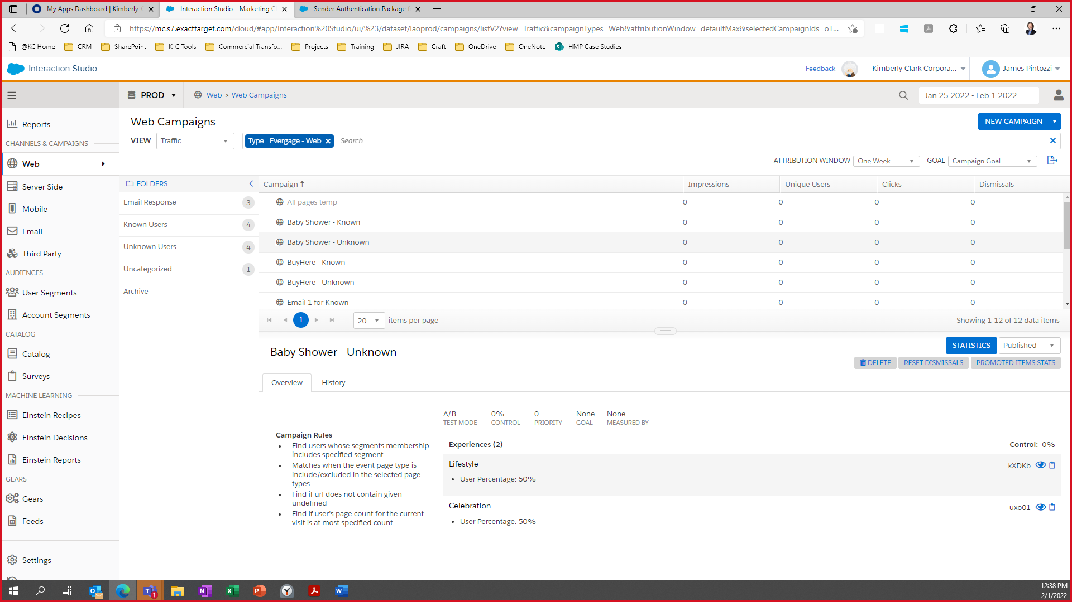

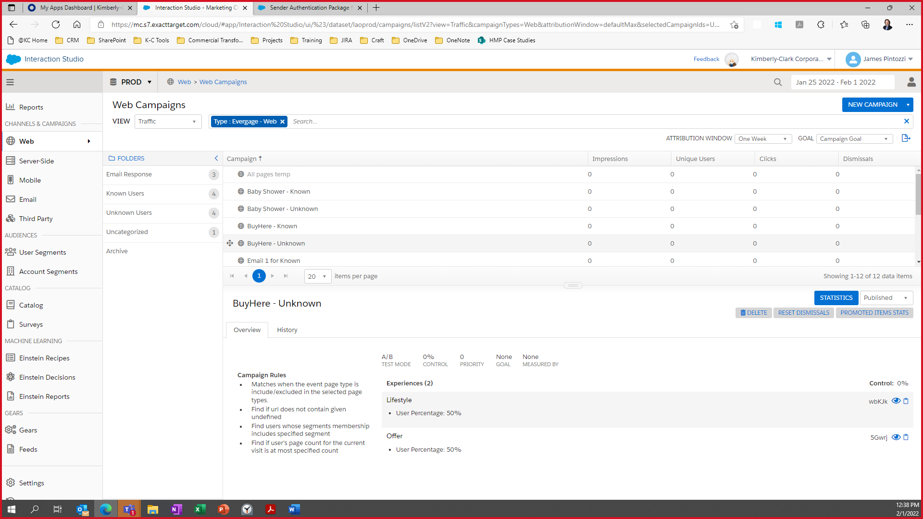

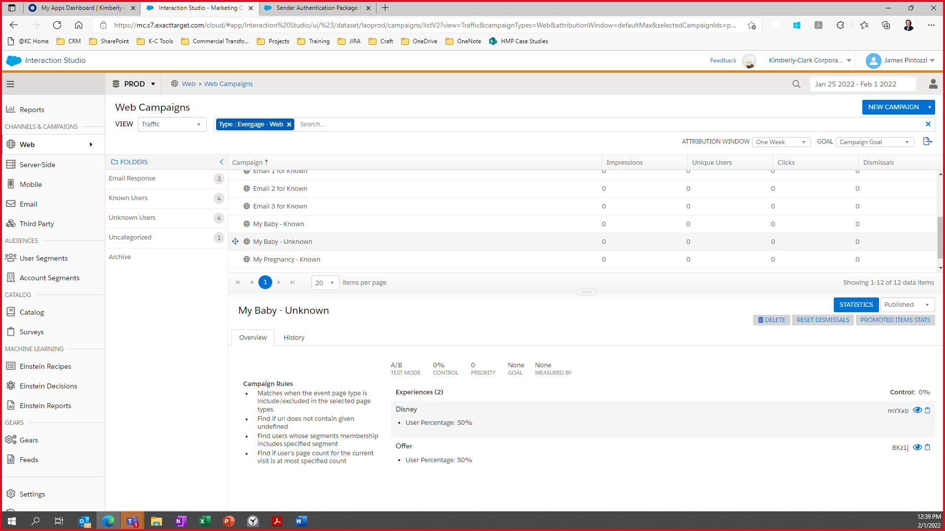

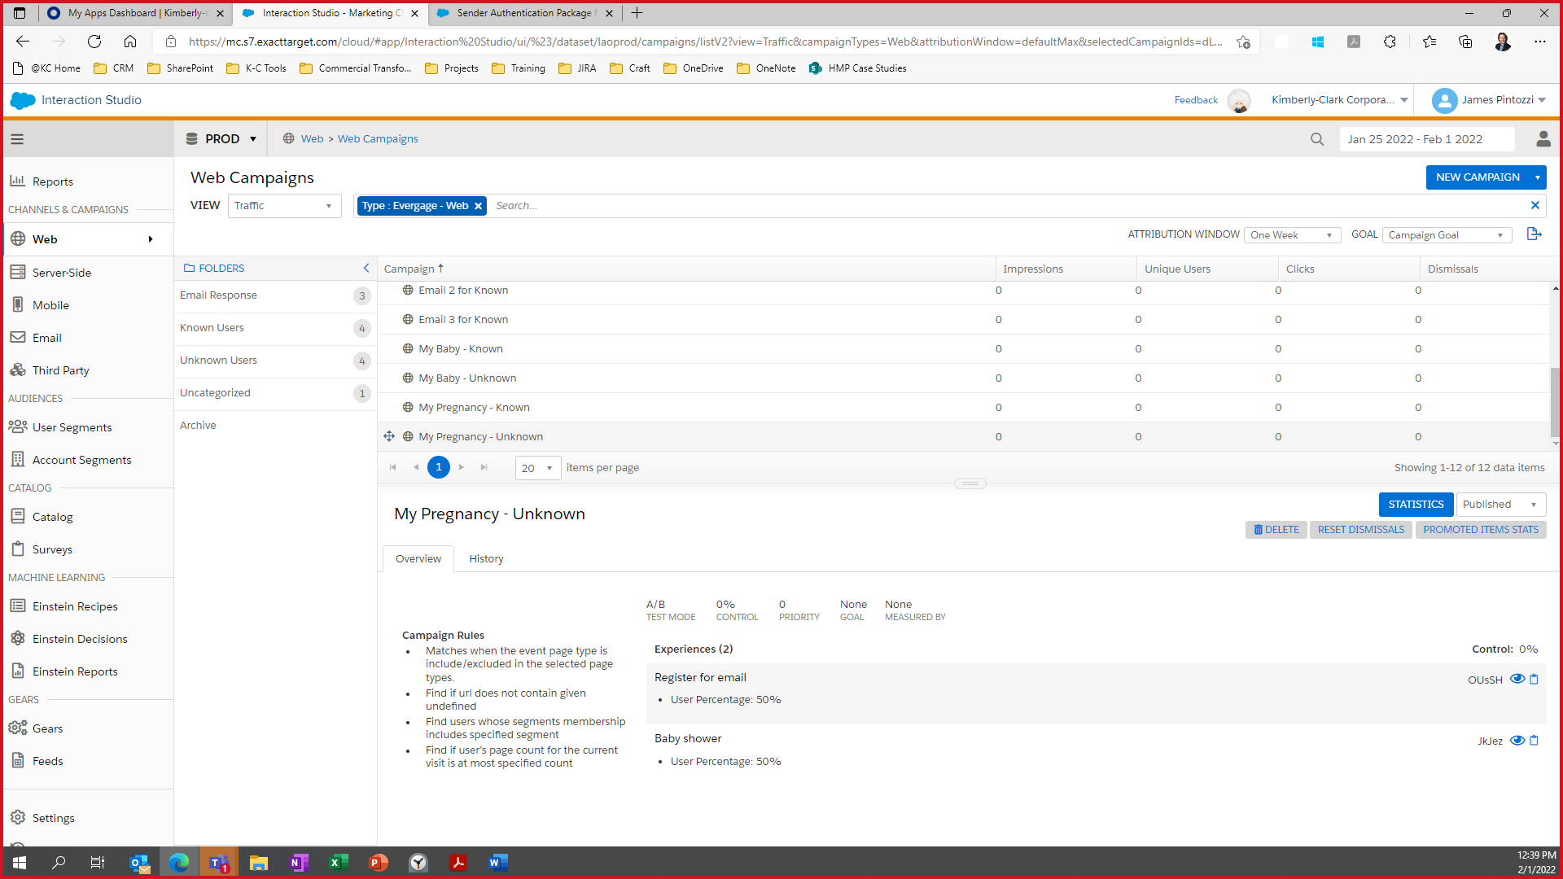

##### Known User

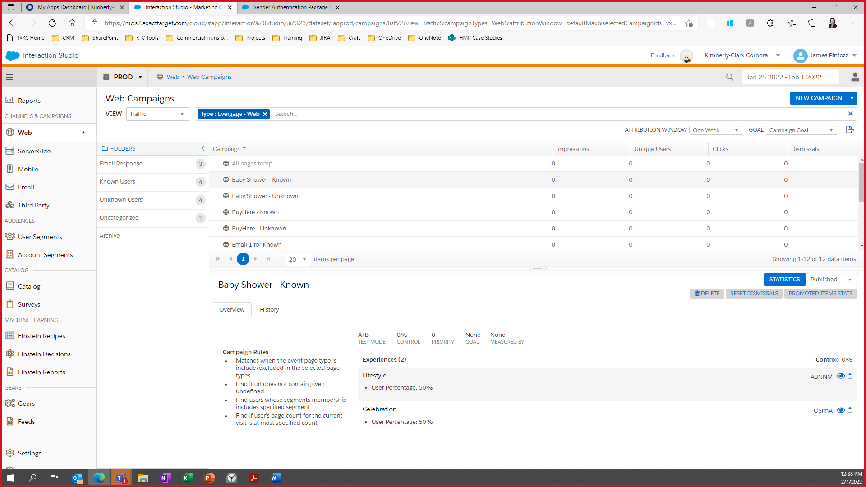

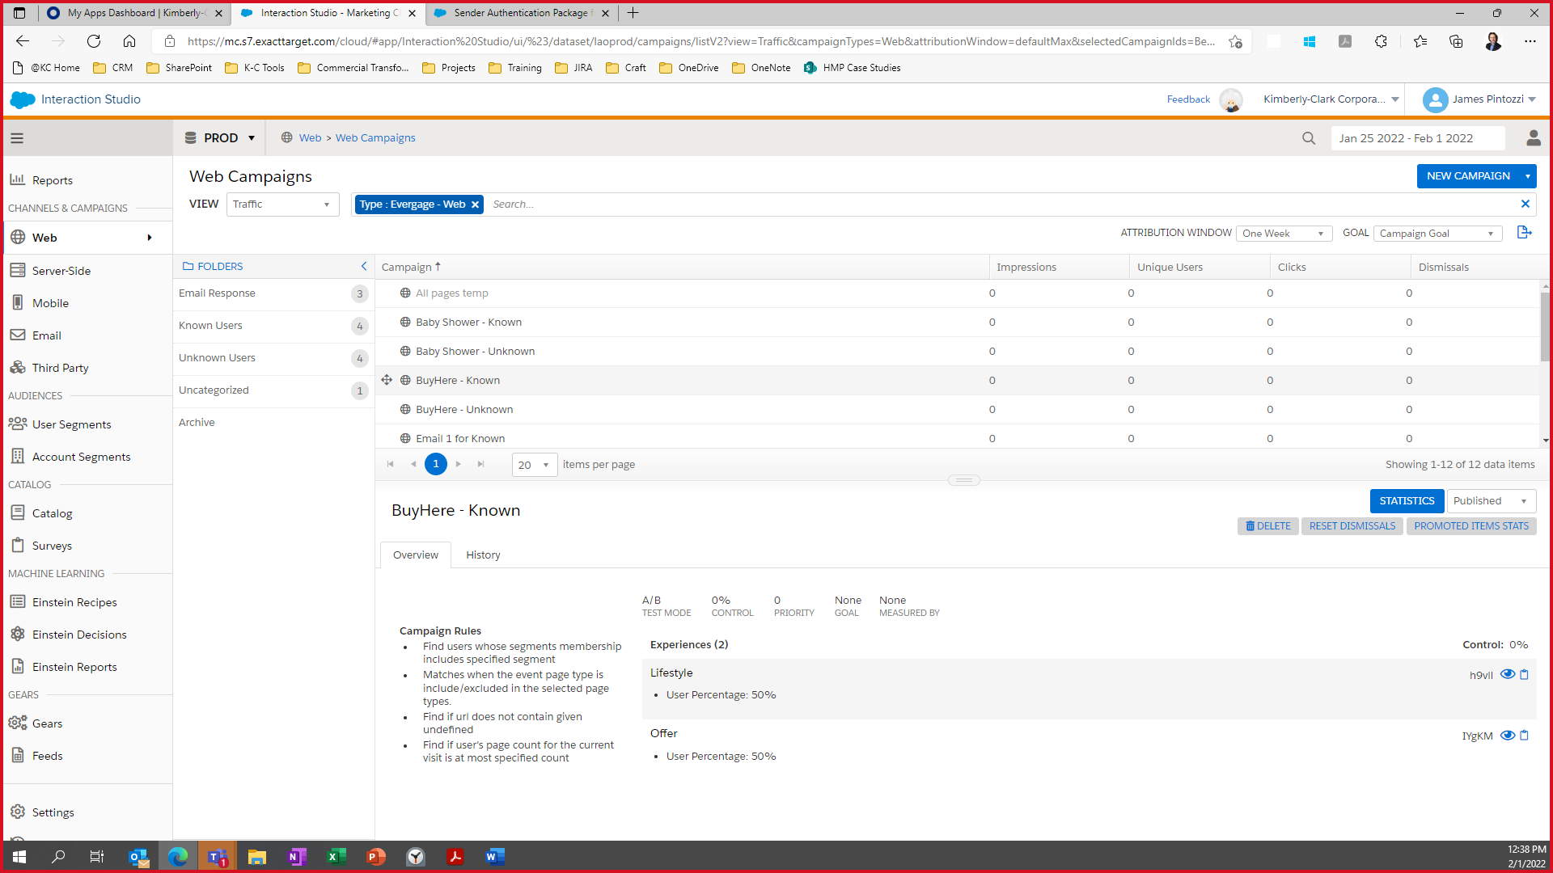

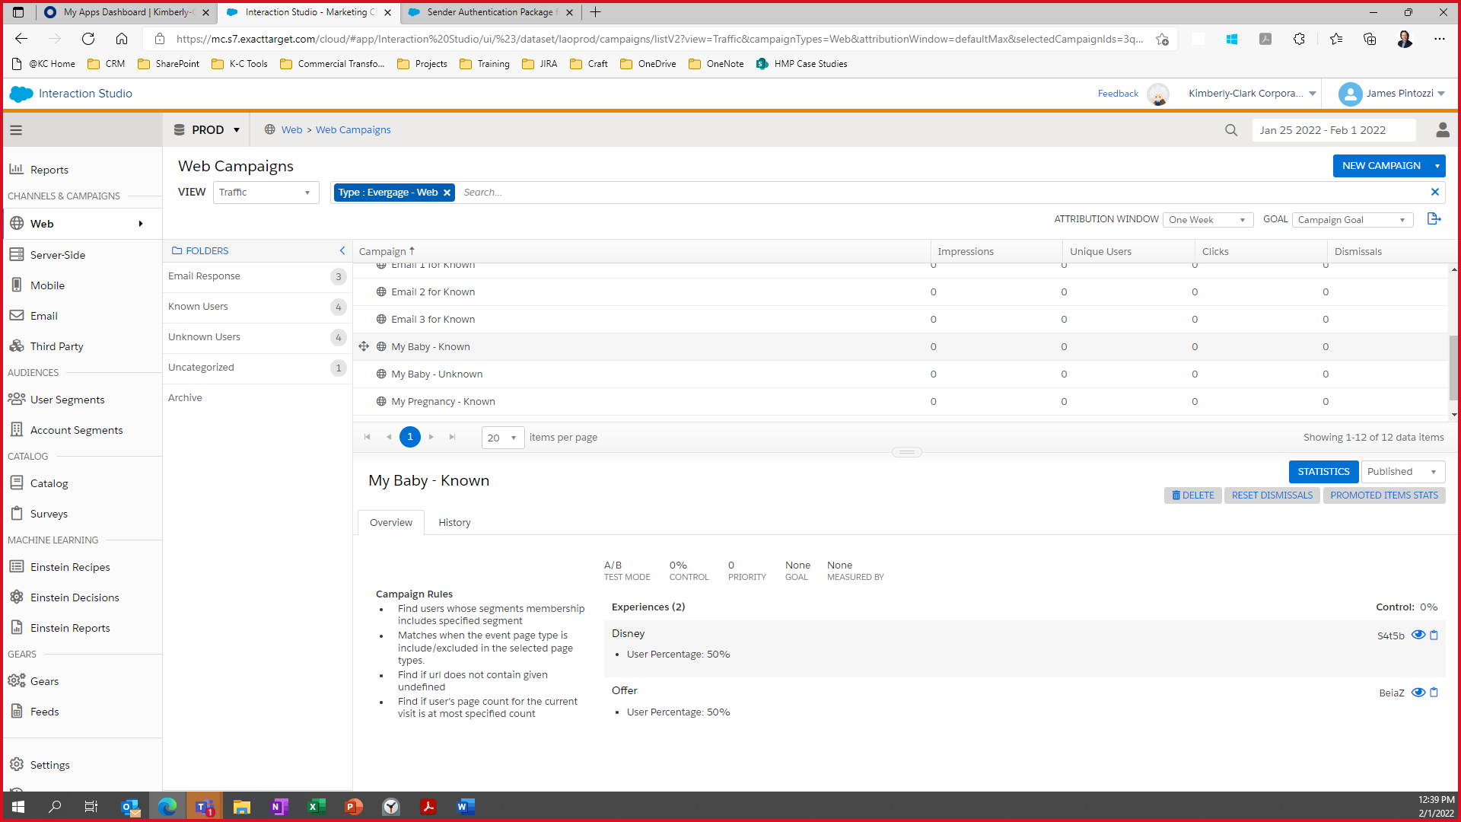

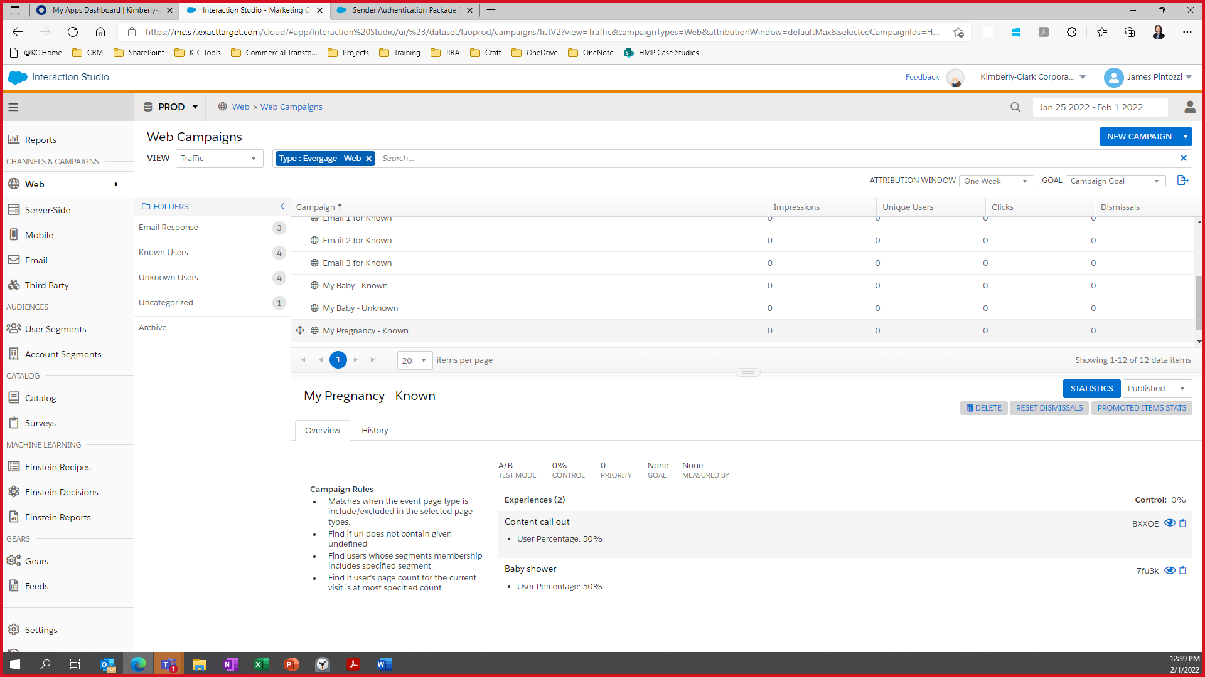

##### Email Response

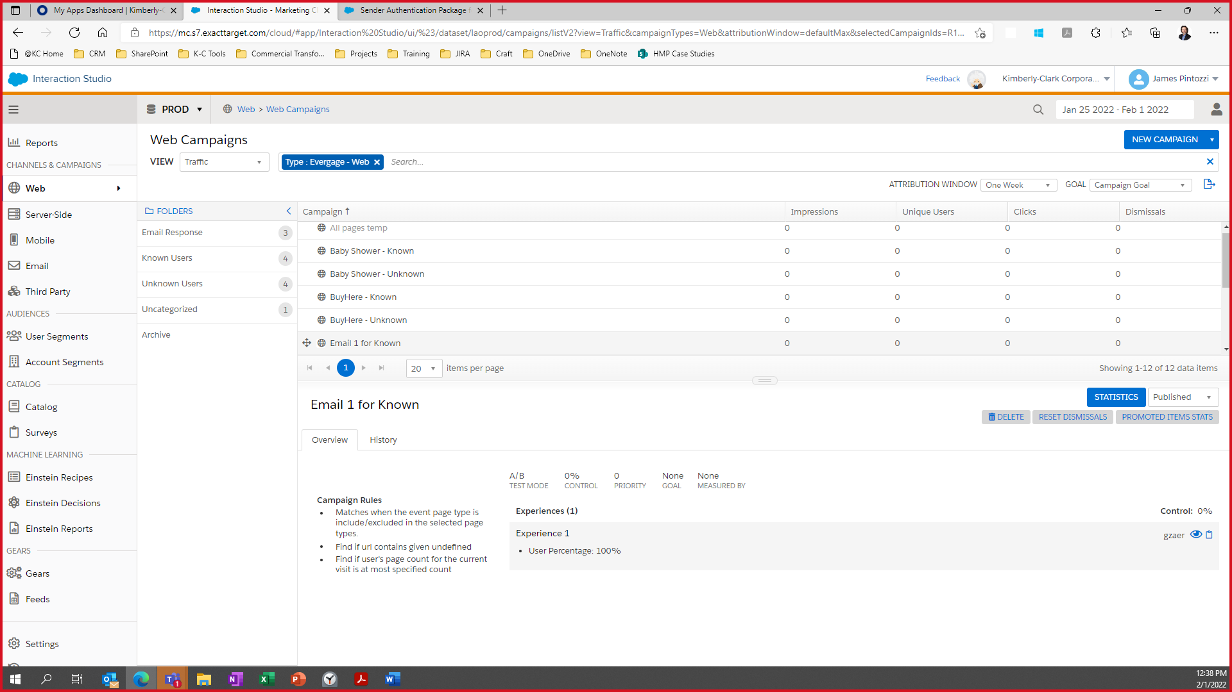

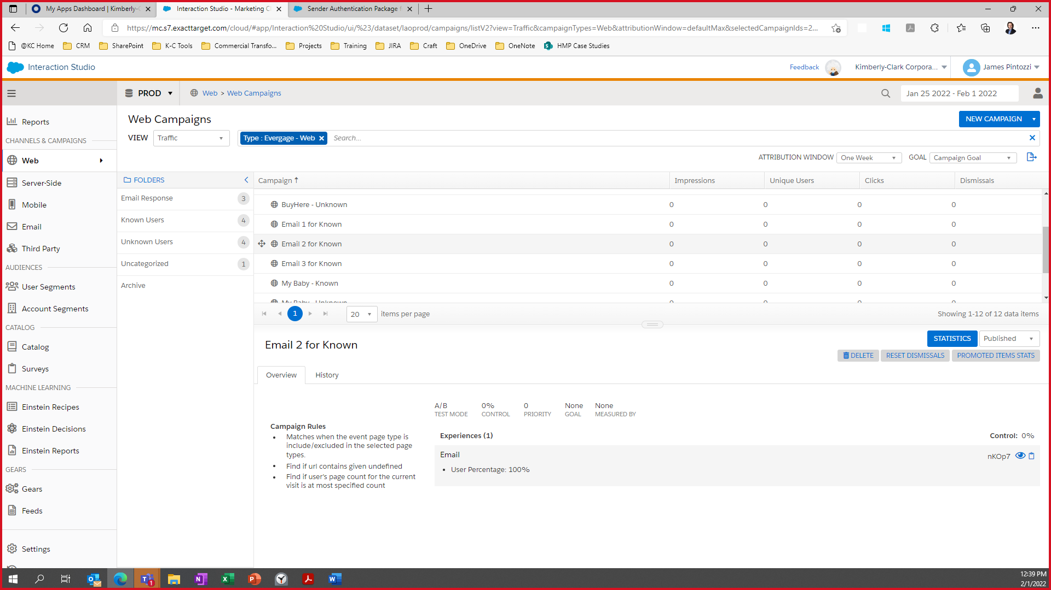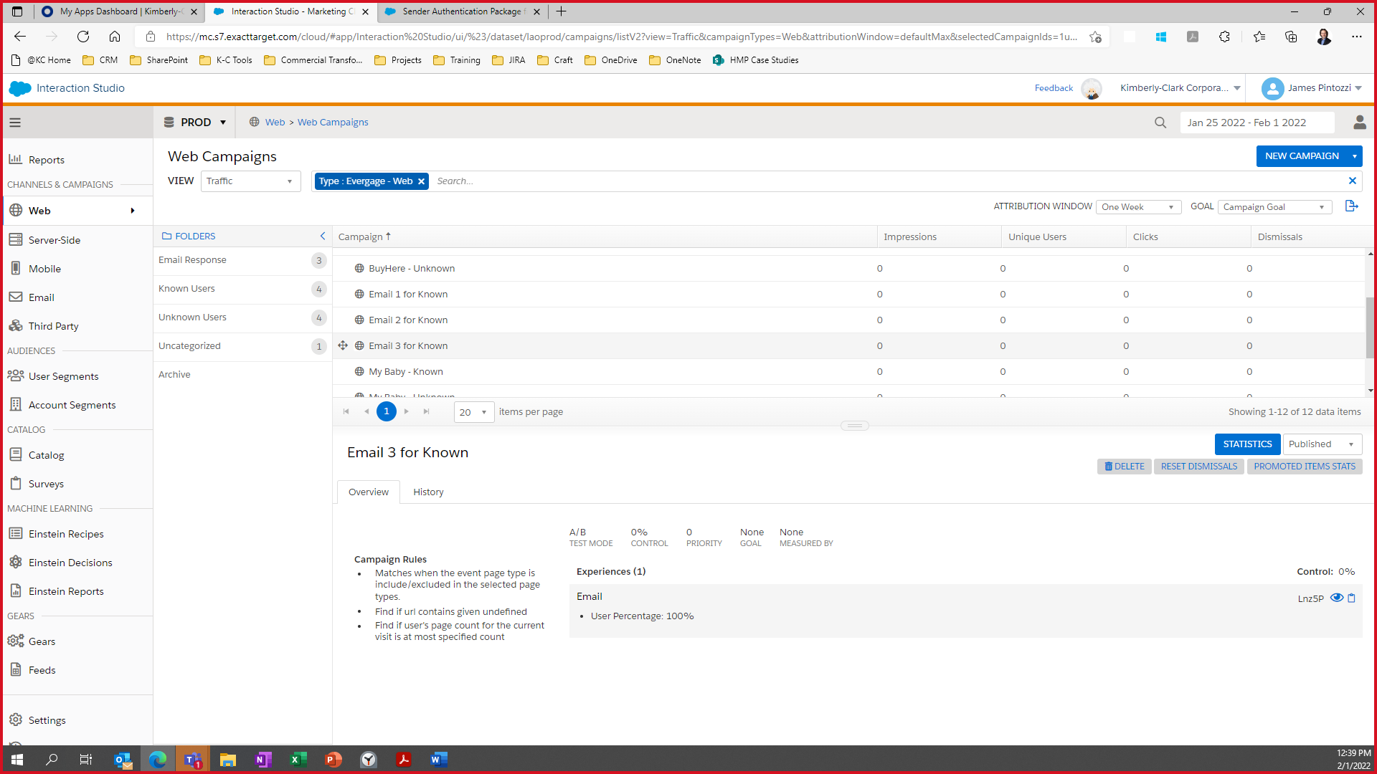

### User Segments

Segmentation is one of the key components of Interaction Studio. You can filter your users and accounts based on a wide range of criteria you define. Segments support a deeper analysis and understanding of your website visitors. You can analyze segment data in Interaction Studio or you can export segment data as a CSV or using a REST API.

More information [here](https://doc.evergage.com/display/EKB/Create+a+Segment)

#### Configuration

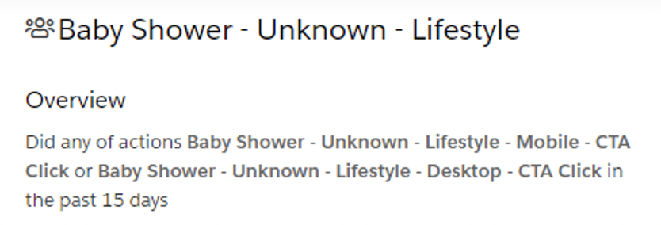 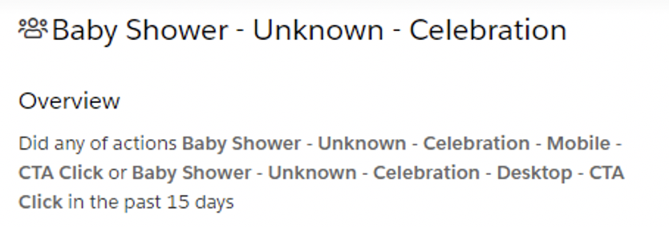

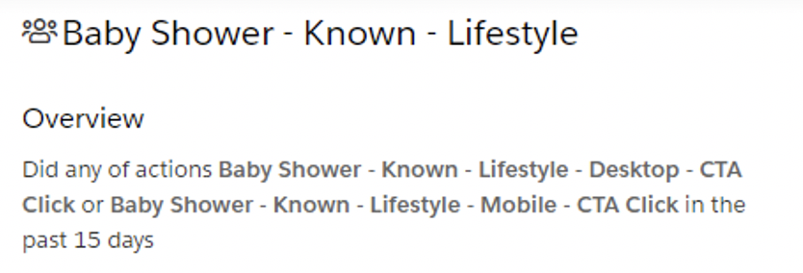 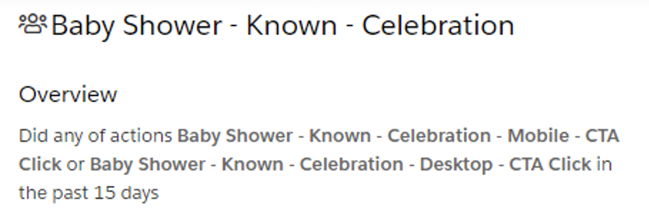

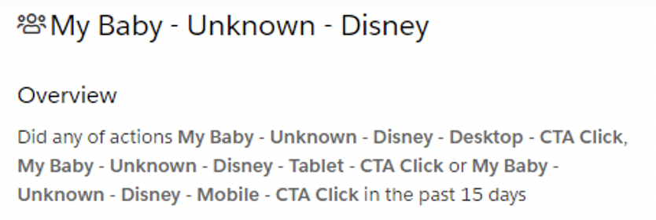 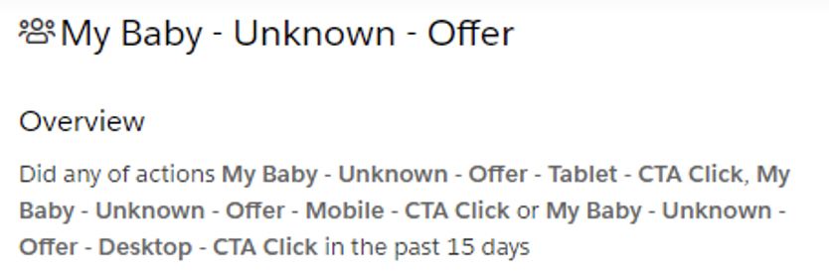

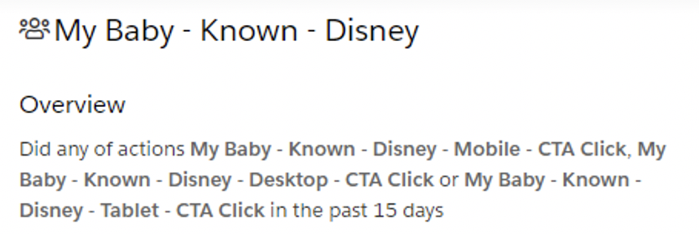 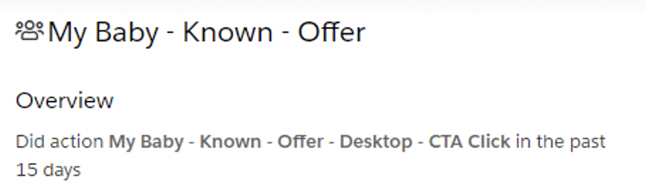

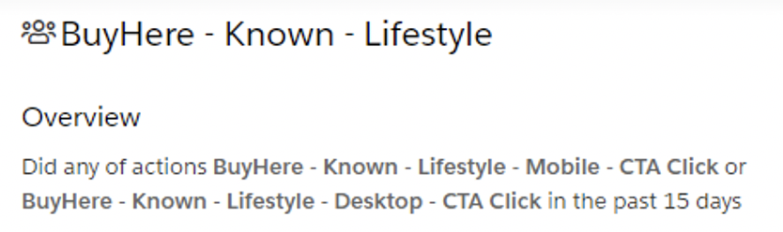 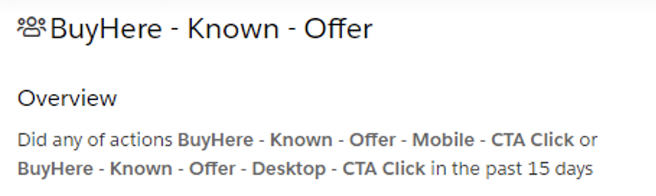

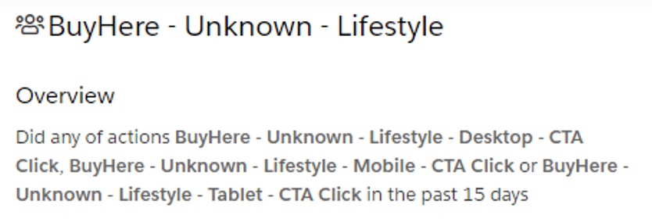 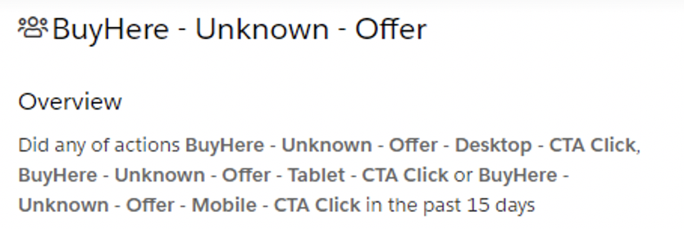

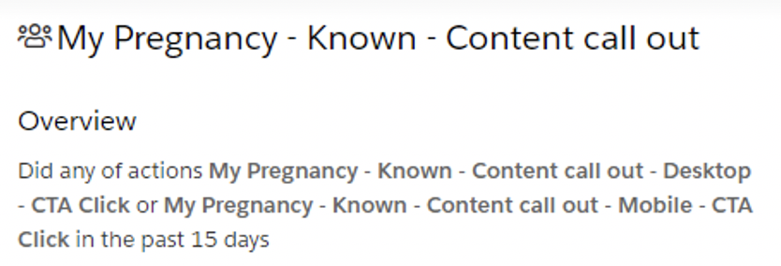 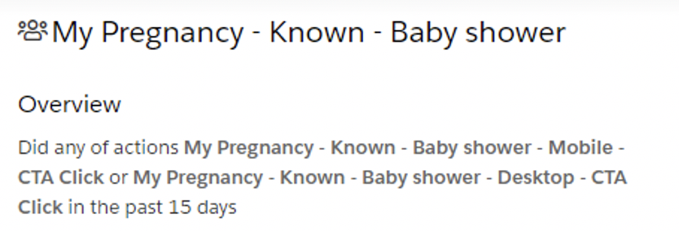

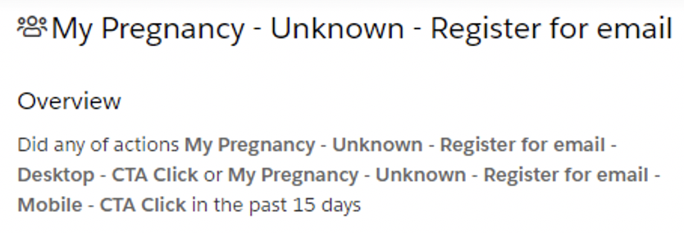 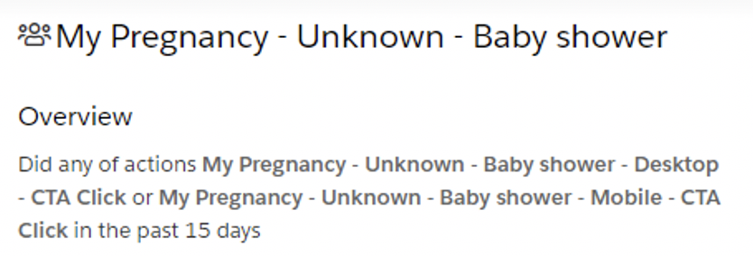

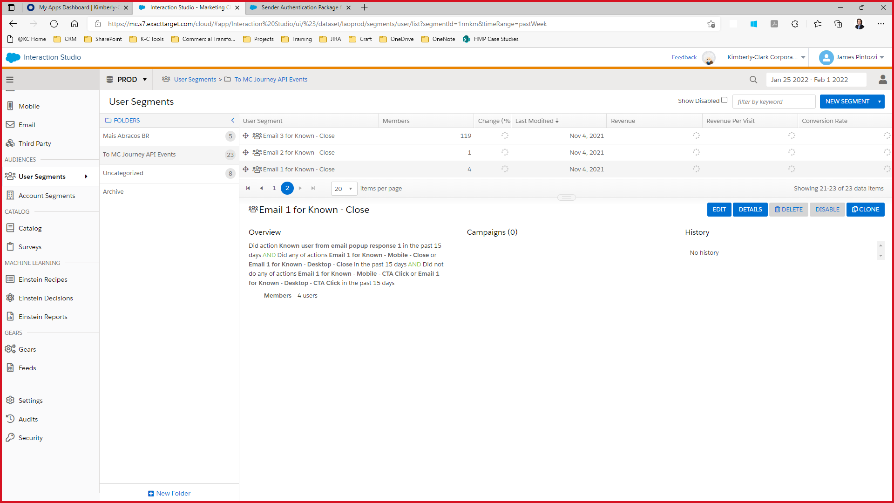 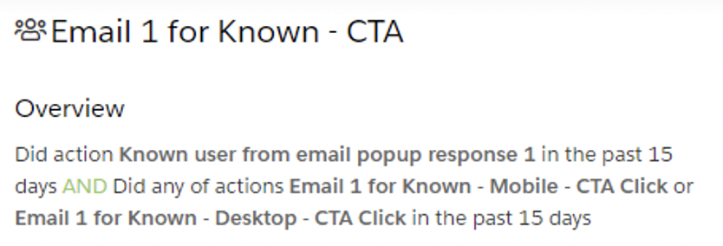

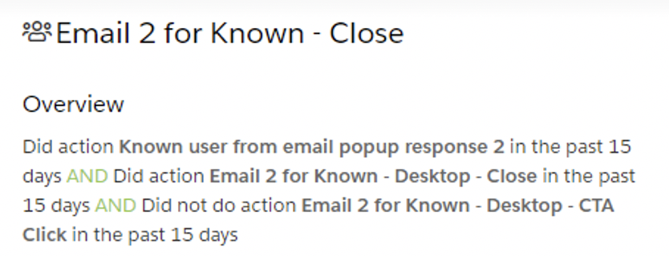 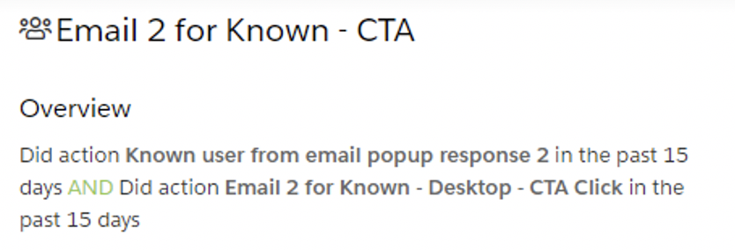

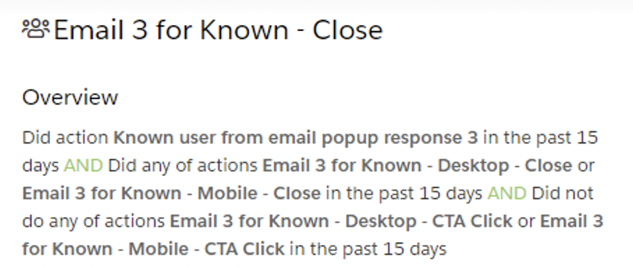 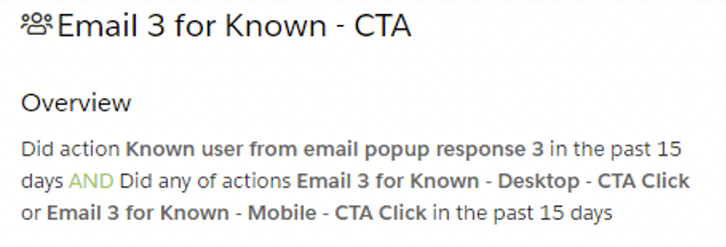

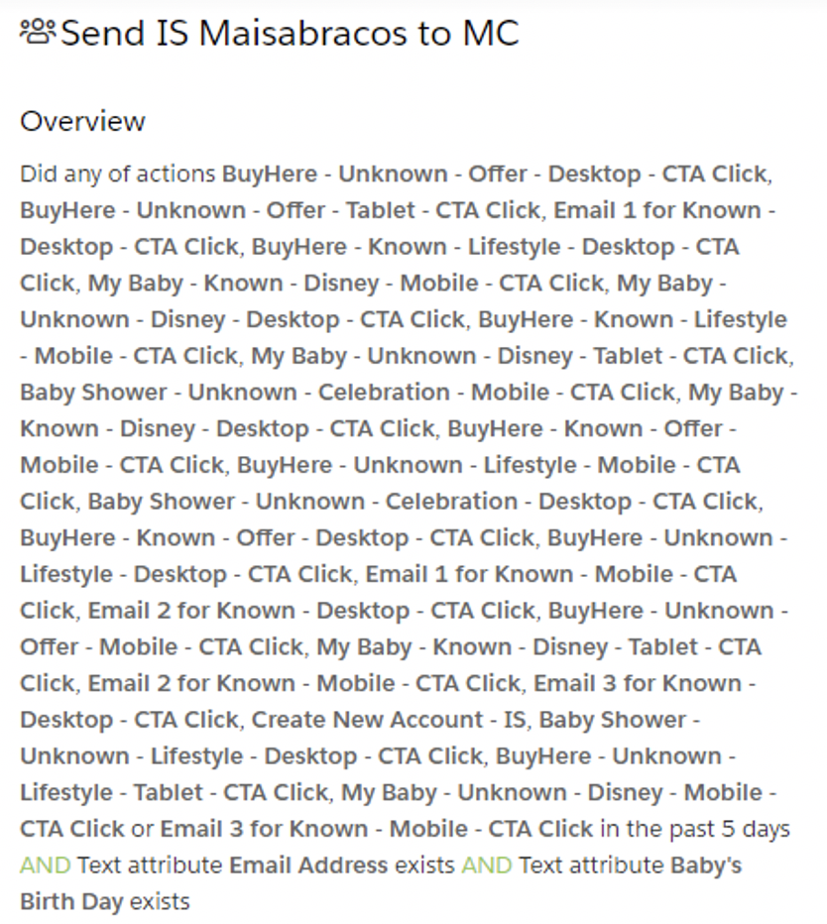

#### Export a Segment to the Interaction Studio SFTP

With the segment file exporter, you can set up a nightly feed or a single time extract to synchronize Interaction Studio segments to the Interaction Studio SFTP. These segments can be leveraged within other systems to target cross channel communications. For example, you could synchronize a segment to Marketing Cloud to target a specific group with an email communication.

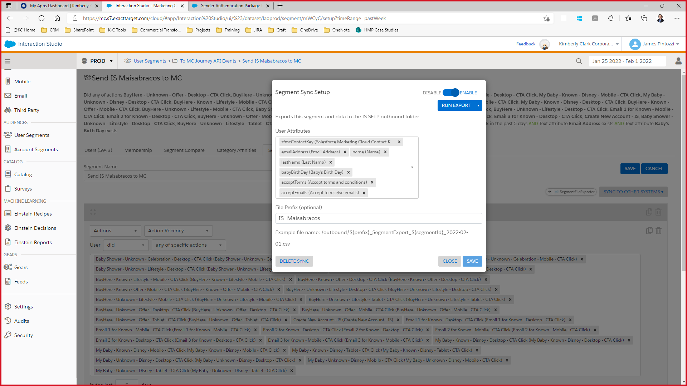

#### Send a User to Journey Builder Upon Segment Join

This [article](https://doc.evergage.com/display/EKB/Send+a+User+to+Journey+Builder+Upon+Segment+Join) details how to configure the Journey Builder Segment Listener so you can use segments to add customers to Journeys within moments of the data changing.

